State of Nebraska State Purchasing Bureau

REQUEST FOR PROPOSAL FOR SERVICES CONTRACT

SOLICITATION NUMBER | RELEASE DATE
123947 O5 | February 17, 2026
OPENING DATE AND TIME | PROCUREMENT CONTACT
March 10, 2026 2:00 p.m. Central Time | Bryon Bratt/ Brenda Sensibaugh

PLEASE READ CAREFULLY!
SCOPE OF SERVICE

The State of Nebraska (State), Department of Administrative Services (DAS), Materiel Division, State Purchasing Bureau (SPB), is issuing this solicitation for a service contract for the purpose of selecting a qualified bidder to provide television broadcast antenna and transmission line removal and installation at KUON-TV transmission tower. A more detailed description can be found in Section V. The resulting contract may not be an exclusive contract as the State reserves the right to contract for the same or similar services from other sources now or in the future.

The term of the contract will be one (1) year commencing upon execution of the contract by the State and the Vendor (Parties). The State reserves the right to extend the period of this contract beyond the termination date when mutually agreeable to the Parties.

In the event that a contract with the awarded bidder(s) is cancelled or in the event that the State needs additional Vendors to supply the solicited services, this solicitation may be used to procure the solicited services for up to twelve (12) months from the date the Intent to Award is posted, provided that 1) the solicited goods or services will be provided by a bidder (or a successive owner) who submitted a response pursuant to this solicitation, 2) the bidder’s solicitation response was evaluated, and 3) the bidder will honor the bidder’s original solicitation response, including the proposed cost, allowing for any price increases that would have otherwise been allowed if the bidder would have received the initial award.

ALL INFORMATION PERTINENT TO THIS SOLICITATION CAN BE FOUND ON THE INTERNET AT: https://das.nebraska.gov/materiel/bidopps.html.

IMPORTANT NOTICE: Pursuant to Neb. Rev. Stat. § 84-602.04, State contracts in effect as of January 1, 2014, and contracts entered into thereafter, must be posted to a public website. The resulting contract, the Solicitation, and the awarded solicitation response will be posted to a public website managed by DAS, which can be found at http://statecontracts.nebraska.gov and https://www.nebraska.gov/das/materiel/purchasing/contract_search/index.php.

In addition and in furtherance of the State’s public records Statute (Neb. Rev. Stat. § 84-712 et seq.), all responses received regarding this Solicitation will be posted to the State Purchasing Bureau public website.

These postings will include the entire solicitation response. Bidder must request that proprietary information be excluded from the posting. The bidder must identify the proprietary information, mark the proprietary information according to state law, and submit the proprietary information in a separate file named conspicuously as "PROPRIETARY INFORMATION". The bidder should submit a detailed written document showing that the release of the proprietary information would give a business advantage to named business competitor(s) and explain how the named business competitor(s) will gain an actual business advantage by disclosure of information. The mere assertion that information is proprietary or that a speculative business advantage might be gained is not sufficient. (See Attorney General Opinion No. 92068, April 27, 1992). THE BIDDER MAY NOT ASSERT THAT THE ENTIRE SOLICITATION IS PROPRIETARY. COST SHEETS WILL NOT BE CONSIDERED PROPRIETARY AND ARE A PUBLIC RECORD IN THE STATE OF NEBRASKA. The State will determine, in its sole discretion, if the disclosure of the information designated by the Bidder as proprietary would 1) give advantage to business competitors and 2) serve no public purpose. The Bidder will be notified of the State’s decision. Absent a determination by the State that the information may be withheld pursuant to Neb. Rev. Stat. § 84-712.05, the State will consider all information a public record subject to disclosure.

If the State determines it is required to release withheld proprietary information, the bidder will be informed. It will be the bidder's responsibility to defend the bidder's asserted interest in non-disclosure.

To facilitate such public postings, with the exception of proprietary information, the State of Nebraska reserves a royalty-free, nonexclusive, and irrevocable right to copy, reproduce, publish, post to a website, or otherwise use any contract, or solicitation response for any purpose, and to authorize others to use the documents. Any individual or entity awarded a contract, or who submits a solicitation response, specifically waives any copyright or other protection the contract, or solicitation response may have; and acknowledges that they have the ability and authority to enter into such waiver. This reservation and waiver are a prerequisite for submitting a solicitation response, and award of a contract. Failure to agree to the reservation and waiver will result in the solicitation response being found non-responsive and rejected.

Any entity awarded a contract or submitting a solicitation response agrees not to sue, file a claim, or make a demand of any kind, and will indemnify and hold harmless the State and its employees, volunteers, agents, and its elected and appointed officials from and against any and all claims, liens, demands, damages, liability, actions, causes of action, losses, judgments, costs, and expenses of every nature, including investigation costs and expenses, settlement costs, and attorney fees and expenses, sustained or asserted against the State, arising out of, resulting from, or attributable to the posting of the contract or solicitation response, awards, and other documents.

TABLE OF CONTENTS
REQUEST FOR PROPOSAL FOR SERVICES CONTRACT i
GLOSSARY OF TERMS v
ACRONYM LIST x
I. PROCUREMENT PROCEDURE 1
A. GENERAL INFORMATION 1
B. PROCURING OFFICE AND COMMUNICATION WITH STATE STAFF AND EVALUATORS 1
C. SCHEDULE OF EVENTS 1
D. WRITTEN QUESTIONS AND ANSWERS 3
E. SECRETARY OF STATE/TAX COMMISSIONER REGISTRATION REQUIREMENTS (Nonnegotiable) 3
F. ETHICS IN PUBLIC CONTRACTING 3
G. DEVIATIONS FROM THE SOLICITATION 3
H. SUBMISSION OF SOLICITATION RESPONSES 3
I. SOLICITATION PREPARATION COSTS 5
J. FAILURE TO COMPLY WITH SOLICITATION 5
K. SOLICITATION RESPONSE CORRECTIONS 5
L. LATE SOLICITATION RESPONSES 5
M. BID OPENING 5
N. SOLICITATION REQUIREMENTS 5
O. EVALUATION COMMITTEE 5
P. EVALUATION OF SOLICITATION RESPONSES 6
Q. BEST AND FINAL OFFER 7
R. REFERENCE AND CREDIT CHECKS 7
S. AWARD 7
T. LUMP SUM OR “ALL OR NONE” SOLICITATION RESPONSES 7
U. REJECTION OF SOLICITATION RESPONSES 7
V. PRICES & COST CLARIFICATION 7
II. TERMS AND CONDITIONS 8
A. GENERAL 8
B. NOTIFICATION 9
C. BUYER’S REPRESENTATIVE 9
D. GOVERNING LAW (Nonnegotiable) 9
E. BEGINNING OF WORK & SUSPENSION OF SERVICES 9
F. AMENDMENT 9
G. CHANGE ORDERS OR SUBSTITUTIONS 9
H. RECORD OF VENDOR PERFORMANCE 10
I. NOTICE OF POTENTIAL VENDOR BREACH 10
J. BREACH 10
K. NON-WAIVER OF BREACH 10
L. SEVERABILITY 10
M. INDEMNIFICATION 10
N. ATTORNEY'S FEES 11
O. ASSIGNMENT, SALE, OR MERGER 11
P. CONTRACTING WITH OTHER NEBRASKA POLITICAL SUBDIVISIONS OF THE STATE OR ANOTHER STATE 11
Q. FORCE MAJEURE 12
R. CONFIDENTIALITY 12
S. EARLY TERMINATION 12
T. CONTRACT CLOSEOUT 12
U. PROHIBITED PRODUCTS 13
V. AMERICANS WITH DISABILITIES ACT 13
III. VENDOR DUTIES 13
A. INDEPENDENT VENDOR / OBLIGATIONS 14
B. FOREIGN ADVERSARY CONTRACTING PROHIBITION ACT CERTIFICATION (Nonnegotiable) 14
C. EMPLOYEE WORK ELIGIBILITY STATUS 14
D. COMPLIANCE WITH CIVIL RIGHTS LAWS AND EQUAL OPPORTUNITY EMPLOYMENT / NONDISCRIMINATION (Nonnegotiable) 15
E. COOPERATION WITH OTHER VENDORS 15
F. DISCOUNTS 15
G. PRICES 15
H. PERMITS, REGULATIONS, LAWS 15
I. INSURANCE REQUIREMENTS 15
J. ANTITRUST 18
K. CONFLICT OF INTEREST 18
L. STATE PROPERTY 18
M. SITE RULES AND REGULATIONS 18
N. ADVERTISING 18
O. NEBRASKA TECHNOLOGY ACCESS STANDARDS (Nonnegotiable) 18
P. DISASTER RECOVERY/BACK UP PLAN 19
Q. DRUG POLICY 19
R. WARRANTY 19
S. TIME IS OF THE ESSENCE 19
IV. PAYMENT 20
A. PROHIBITION AGAINST ADVANCE PAYMENT (Nonnegotiable) 20
B. TAXES (Nonnegotiable) 20
C. INVOICES 20
D. INSPECTION AND APPROVAL 20
E. PAYMENT (Nonnegotiable) 21
F. LATE PAYMENT (Nonnegotiable) 21
G. SUBJECT TO FUNDING / FUNDING OUT CLAUSE FOR LOSS OF APPROPRIATIONS (Nonnegotiable) 21
H. RIGHT TO AUDIT (First Paragraph is Nonnegotiable) 21
V. PROJECT DESCRIPTION AND SCOPE OF WORK 22
A. PROJECT OVERVIEW 22
B. PROJECT ENVIRONMENT 22
C. PROJECT REQUIREMENTS 25
D. TIMELINE REQUIREMENTS 29
E. SCOPE OF WORK 29
F. WORK PLAN 30
G. TECHNICAL REQUIREMENTS 31
H. PROJECT PLANNING AND MANAGEMENT 31
I. EVALUATE CURRENT PROJECT ENVIRONMENT 32
J. PROVIDE POST IMPLEMENTATION SUPPORT 32
K. DELIVERABLES 32
VI. SOLICITATION RESPONSE INSTRUCTIONS 33
A. SOLICITATION RESPONSE SUBMISSION 33
CONTRACTUAL AGREEMENT FORM 36

GLOSSARY OF TERMS

Acceptance Test Procedure: Benchmarks and other performance criteria, developed by the State or other sources of testing standards, for measuring the effectiveness of products or goods and the means used for testing such performance

Addendum: A written correction or alteration to a document during the solicitation process (e.g., Questions and Answers, Revised Schedule of Events, Addendum to Contract Award)

Agency: All officers of the state, departments, bureaus, boards, commissions, councils, and institutions receiving legislative appropriations

Agent/Representative: A person authorized to act on behalf of another

Amend: To alter or change by adding, subtracting, or substituting

Amendment: A written correction or alteration to a document

Appropriation: Legislative authorization to expend public funds for a specific purpose; money set apart for a specific use

Automated Clearing House (ACH): Electronic network for financial transactions in the United States

Award: All purchases, leases, or contracts which are based on competitive solicitations will be awarded according to the provisions in the solicitation

Best and Final Offer (BAFO): In a competitive solicitation, the final offer submitted which contains Vendor’s most favorable terms for price

Bid: See Solicitation Response

Bid Opening: The process of opening correctly submitted solicitation responses at the time and place specified in the written solicitation and in the presence of any bidder who wishes to attend

Bidder: A Vendor who submits a Solicitation Response

Breach: Violation of a contractual obligation by failing to perform or repudiation of one’s own promise

Business: Any corporation, partnership, individual, sole proprietorship, joint-stock company, joint venture, or any other private legal entity

Business Day: Any weekday, except State-recognized holidays

Calendar Day: Every day shown on the calendar including Saturdays, Sundays, and State/Federal holidays

Cancellation: To call off or revoke a solicitation, purchase order, or contract without expectation of conducting or performing at a later time

Catalog/Non-Core: A printed or electronic list of products a Vendor may provide at a discounted rate or discount off list price to the State. Initial contract award(s) is not based on Catalog/Non-Core items

Central Processing Unit (CPU): Any computer or computer system that is used by the State to store, process, or retrieve data or perform other functions using Operating Systems and applications software

Change Order: Document that provides amendments to an executed purchase order or contract

Collusion: An agreement or cooperation between two or more persons or entities to accomplish a fraudulent, deceitful, or unlawful purpose

Commodities: Any equipment, material, supply, or goods; anything movable or tangible that is provided or sold

Commodities Description: Detailed descriptions of the items to be purchased; may include information necessary to obtain the desired quality, type, color, size, shape, or special characteristics necessary to perform the work intended to produce the desired results

Competition: The effort or action of two or more commercial interests to obtain the same business from third parties

Confidential Information: See Proprietary Information

Contract: An agreement between two or more parties creating obligations that are enforceable or otherwise recognizable at law; the writing that sets forth such an agreement

Contract Administration: The management of the contract which includes and is not limited to contract signing, contract amendments and any necessary legal actions

Contract Award: Document that officially awards a contract to a bidder(s) as the result of a competitive solicitation or a vendor(s) in a contract that qualifies for an exception or exemption from the competitive bidding requirements of the State Procurement Act

Contract Management: The management of day-to-day activities at the agency which includes but is not limited to ensuring deliverables are received, specifications are met, handling meetings and making payments to the Vendor

Contract Period: The duration of the contract

Contractor: See Vendor

Cooperative Purchasing: The combining of requirements of two or more political entities to obtain advantages of volume purchases, reduction in administrative expenses or other public benefits

Copyright: A property right in an original work of authorship fixed in any tangible medium of expression, giving the holder the exclusive right to reproduce, adapt and distribute the work

Cost Sheet: A required document that is completed by the vendor in the prescribed format to show the vendor’s pricing to provide the commodities or perform the services requested.

Critical Program Error: Any Program Error, whether or not known to the State, which prohibits or significantly impairs use of the Licensed Software as set forth in the documentation and intended in the contract

Customer Service: The process of ensuring customer satisfaction by providing assistance and advice on those commodities or services provided by a Vendor

Default: The omission or failure to perform a contractual duty

Deviation: Any proposed change(s) or alteration(s) to either the terms and conditions or deliverables within the scope of the written solicitation or contract

Evaluation: The process of examining a solicitation response after opening to determine the bidder’s responsibility, responsiveness to requirements, and to ascertain other characteristics of the solicitation response that relate to determination of the successful award

Evaluation Committee: Individual(s) identified by the agency that leads the solicitation to evaluate solicitation responses

Extension: Continuance of a contract for a specified duration upon the agreement of the parties beyond the original Contract Period; not to be confused with “Renewal Period”

Free on Board (F.O.B.) Destination: The delivery charges are included in the quoted price and prepaid by the Vendor. Vendor is responsible for all claims associated with damages during delivery of product.

Free on Board (F.O.B.) Point of Origin: The delivery charges are not included in the quoted price and are the responsibility of the agency. Agency is responsible for all claims associated with damages during delivery of product

Foreign Corporation: A foreign corporation that was organized and chartered under the laws of another state, government, or country

Goods: See Commodities

Installation Date: The date when the procedures described in “Installation by Vendor“ and “Installation by State” as found in the solicitation or contract are completed

Interested Party: A person acting in their personal capacity or an entity entering into a contract or other agreement creating a legal interest therein

Late Solicitation Response: A solicitation response received after the Opening Date and Time

Licensed Software Documentation: The user manuals and any other materials in any form or medium customarily provided by the Vendor to the users of the Licensed Software which will provide the State with sufficient information to operate, diagnose, and maintain the Licensed Software properly, safely, and efficiently

Mandatory: Required, compulsory, or obligatory

May: Discretionary, permitted; used to express possibility

Module (see System): A collection of routines and data structures that perform a specific function of software

Must: See Shall

National Institute for Governmental Purchasing (NIGP): National Institute of Governmental Purchasing – Source used for assignment of universal commodity codes to goods and services

Non-core: See Catalog

Non-Responsive Solicitation Response: Any solicitation response that does not comply with the requirements of the solicitation or cannot be evaluated against the other solicitation responses

Nonnegotiable: These clauses are controlled by state law and are not subject to negotiation

Opening Date and Time: Specified date and time for the opening of received, labeled, and sealed formal solicitation responses

Operating System: The control program in a computer that provides the interface to the computer hardware and peripheral devices, and the usage and allocation of memory resources, processor resources, input/output resources, and security resources

Outsourcing: The contracting out of a business process that an organization may have previously performed internally or for which an organization has a new need to an independent organization from which the process is purchased back

Payroll & Financial Center (PFC): Electronic procurement system of record

Performance Bond: An insurance agreement accompanied by a monetary commitment by which a third party (the surety) accepts liability and guarantees that the Vendor fulfills any and all obligations under the contract

Personal Property: See Commodities

Platform: A specific hardware and Operating System combination that is different from other hardware and Operating System combinations to the extent that a different version of the Licensed Software product is required to execute properly in the environment established by such hardware and Operating System combination

Point of Contact (POC): The person designated to receive communications and to communicate

Product: Something that is distributed commercially for use or consumption and that is usually (1) tangible personal property, (2) the result of fabrication or processing, and (3) an item that has passed through a chain of commercial distribution before ultimate use or consumption

Program Error: Code in Licensed Software that produces unintended results or actions or that produces results or actions other than those described in the specifications. A program error includes, without limitation, any Critical Program Error.

Program Set: The group of programs and products, including the Licensed Software specified in the solicitation, plus any additional programs and products licensed by the State under the contract for use by the State

Project: The total scheme, program, or method worked out for the accomplishment of an objective, including all documentation, commodities, and services to be provided under the contract

Proposal: See Solicitation Response

Proprietary Information: Trade secrets, academic and scientific research work that is in progress and unpublished or other information that if released would give advantage to business competitors and service no public purpose. See Neb. Rev. Stat. § 84-712.05(3). In accordance with Attorney General Opinions 92068 and 97033, proof that information is proprietary requires identification of specific named competitor(s) advantaged by release of the information and the demonstrated advantage the named competitor(s) would gain by the release of information.

Protest/Grievance:
A complaint about a governmental action or decision related to the solicitation or resultant contract under SPB’s Protest Policy.

Quote: See Solicitation Response

Recommended Hardware Configuration: The data processing hardware (including all terminals, auxiliary storage, communication, and other peripheral devices) to the extent used by the State as recommended by the Vendor

Release Date: The date of public release of the solicitation

Renewal Period: Optional contract periods subsequent to the original Contract Period for a specified duration with previously agreed to terms and conditions; not to be confused with “Extension”

Request for Proposal (RFP): See Solicitation

Responsible Bidder: A Vendor who has the capability in all respects to perform fully and lawfully all requirements with integrity and reliability to assure good faith performance

Responsive Bidder: A Vendor who has submitted a solicitation response which conforms to all requirements of the solicitation

Shall: An order/command; mandatory

Should: Expected; suggested, but not necessarily mandatory

Software License: Legal instrument with or without printed material that governs the use or redistribution of licensed software

Solicitation: A formal invitation to receive quotes in the form of a Request for Proposal or Invitation to Bid

Solicitation Bond: An insurance agreement, accompanied by a monetary commitment, by which a third party (the surety) accepts liability and guarantees that the Vendor will not withdraw the solicitation response

Solicitation Conference: A meeting scheduled for the purpose of clarifying a written solicitation and related expectations

Solicitation Response: An offer, quote, bid, or proposal submitted by a Vendor in response to a Solicitation

Specifications: The detailed statement, especially of the measurements, quality, materials, and functional characteristics, or other items to be provided under a contract

Subcontractor: Individual or entity with whom the Vendor enters a contract to perform a portion of the work awarded to the Vendor

System (see Module): Any collection or aggregation of two (2) or more Modules that is designed to function, or is represented by the Vendor as functioning or being capable of functioning, as an entity

Termination:
Occurs when either Party, under a power created by agreement or law, puts an end to the contract prior to the stated expiration date; all obligations that are still executory on both sides are discharged but any right based on prior breach or performance survives

Third-Party: Any person or entity, including but not limited to fiduciaries, shareholders, owners, officers, managers, employees, legally disinterested persons, and subcontractors or agents, and their employees. It shall not include any entity or person who is an interested party to the contract or agreement

Trade Secret: Information, including but not limited to, a drawing, formula, pattern, compilation, program, device, method, technique, code, or process that (a) derives independent economic value, actual or potential, from not being known to, and not being ascertainable by proper means by, other persons who can obtain economic value from its disclosure or use; and (b) is the subject of efforts that are reasonable under the circumstances to maintain its secrecy (see Neb. Rev. Stat. § 87-502(4))

Trademark: A word, phrase, logo, or other graphic symbol used by a manufacturer or Vendor to distinguish its product from those of others, registered with the U.S. Patent and Trademark Office

Upgrade: Any change that improves or alters the basic function of a product of service

Vendor: An individual or entity lawfully conducting business with the State, or licensed to do so, who seeks to provide and contract for goods or services under the terms of a Solicitation and/or Contract

Vendor Performance Report: A report completed by the using agency and submitted to State Purchasing Bureau documenting products or services delivered or performed which exceed or fail to meet the terms of the purchase order, contract, and/or solicitation specifications

Will: See Shall

Work Day: See Business Day

ACRONYM LIST

ACH – Automated Clearing House

ARO – After Receipt of Order

BAFO – Best and Final Offer

COI – Certificate of Insurance

CPU – Central Processing Unit

DAS – Department of Administrative Services

F.O.B. – Free on Board

ICT – Information and Communication Technology

ITB – Invitation to Bid

NETC – Nebraska Educational Telecommunications Commission

NIGP – National Institute for Governmental Purchasing

PA – Participating Addendum

RFP – Request for Proposal

SPB – State Purchasing Bureau

- PROCUREMENT PROCEDURE

  - GENERAL INFORMATION
This solicitation is designed to solicit responses from qualified bidders who will be responsible for providing television broadcast antenna and transmission line removal and installation at KUON-TV transmission tower at a competitive and reasonable cost.

Solicitation responses shall conform to all instructions, conditions, and requirements included in the solicitation. Prospective bidders are expected to carefully examine all documents, schedules, and requirements in this solicitation, and respond to each requirement in the format prescribed. Solicitation responses may be found non-responsive if they do not conform to the solicitation.

  - PROCURING OFFICE AND COMMUNICATION WITH STATE STAFF AND EVALUATORS
Procurement responsibilities related to this solicitation reside with the State Purchasing Bureau. The point of contact (POC) for the procurement is as follows:

RFP Number: 123947 O5
Name: Bryon Bratt/ Brenda Sensibaugh Procurement Contract Officer(s)
Agency: State Purchasing Bureau
Address: 1526 K Street, Suite 130
Lincoln, NE 68508
Telephone: 402-471-6500
E-Mail: as.materielpurchasing@nebraska.gov

From the date the solicitation is issued until the Intent to Award is issued, communication from the bidder is limited to the POC listed above. After the Intent to Award is issued, the bidder may communicate with individuals the State has designated as responsible for negotiating the contract on behalf of the State. No member of the State Government, employee of the State, or member of the Evaluation Committee is empowered to make binding statements regarding this solicitation. The POC will issue any answers, clarifications, or amendments regarding this solicitation in writing. Only the SPB or awarding agency can award a contract. Bidders shall not have any communication with or attempt to communicate or influence any evaluator involved in this solicitation.

The following exceptions to these restrictions are permitted:

    - Contact made pursuant to pre-existing contracts or obligations;

    - Contact required by the schedule of events or an event scheduled later by the POC; and

    - Contact required for negotiation and execution of the final contract.

The State reserves the right to reject a bidder’s solicitation response, withdraw an Intent to Award, or terminate a contract if the State determines there has been a violation of these procurement procedures.

  - SCHEDULE OF EVENTS
The State expects to adhere to the procurement schedule shown below, but all dates are approximate and subject to change.

NOTE: All ShareFile links in the Schedule of Events below, are unique links for each schedule step. Please click the correct link for the upload step you are requesting.

Schedule of Events
ACTIVITY |  | DATE/TIME
- 1 | Release solicitation | February 17, 2026
 | Last day to submit written questions.  ShareFile link for uploading questions https://nebraska.sharefile.com/r-rf12a14eabdd8486ea684f973de753006 | February 23, 2026
- 1 | State responds to written questions through solicitation “Addendum” to be posted to the Internet at: http://das.nebraska.gov/materiel/bidopps.html | March 2, 2026
- 1 | Electronic Solicitation Opening – Online Via Webex  IT IS THE BIDDER’S RESPONSIBILTY TO UPLOAD ELECTRONIC FILES BY OPENING DATE AND TIME. EXCEPTIONS WILL NOT BE MADE FOR TECHNOLOGY ISSUES.  ShareFile Electronic Solicitation Submission Link: https://nebraska.sharefile.com/r-r20560ffce5a84910869420fffb223882  Webinar topic:  123947 O5 Television broadcast antenna and transmission line removal and installation  Date and time:  Tuesday, March 10, 2026 2:00 PM | (UTC-06:00) Central Time (US & Canada)  Join link:  https://sonvideo.webex.com/sonvideo/j.php?MTID=ma0009f92f83c4eea3003a082170e2ab4  Webinar number:  2490 551 0214  Webinar password:  4hWQjrJpi48 (44975757 when dialing from a phone or video system)  Join by phone  +1-408-418-9388 United States Toll  Access code: 249 055 10214 | March 10, 2026  2:00 PM  Central Time
- 1 | Review for conformance to solicitation requirements | March 11, 2026- March 12, 2026
- 1 | Evaluation period | March 13, 2026- March 24, 2026
- 1 | Post “Intent to Award” to the Internet at: https://das.nebraska.gov/materiel/bidopps.html | March 25, 2026
- 1 | Contract finalization period | TBD
- 1 | Contract award | TBD
- 2 | Contract start date | TBD

  - WRITTEN QUESTIONS AND ANSWERS
Questions regarding the meaning or interpretation of any solicitation provision must be submitted in writing to State Purchasing Bureau and clearly marked “Solicitation Number 123947 O5; Television broadcast antenna and transmission line removal and installation at KUON-TV transmission tower Questions”. The POC is not obligated to respond to questions that are received late per the Schedule of Events.

Bidders should submit questions for any items upon which assumptions may be made when preparing a response to the solicitation. Any solicitation response containing assumptions may be deemed non-responsive and may be rejected by the State. Solicitation responses will be evaluated without consideration of any known or unknown assumptions of a bidder. The contract will not incorporate any known or unknown assumptions of a bidder.

Questions should be uploaded using the ShareFile link provided in the solicitation Schedule of Events, Section I.C.
It is recommended that bidders submit questions using the following format:

RFP Section Reference | RFP Page Number | Question

Written answers will be posted at https://das.nebraska.gov/materiel/bidopps.html per the Schedule of Events.

  - SECRETARY OF STATE/TAX COMMISSIONER REGISTRATION REQUIREMENTS (Nonnegotiable)
All bidders must be authorized to transact business in the State of Nebraska and comply with all Nebraska Secretary of State Registration requirements. The bidder who is the recipient of an Intent to Award may be required to certify that it has complied and produce a true and exact copy of its current (within ninety (90) calendar days of the intent to award) Certificate or Letter of Good Standing, or in the case of a sole proprietorship, provide written documentation of sole proprietorship and complete the United States Citizenship Attestation Form, available on the Department of Administrative Services website at:
https://das.nebraska.gov/materiel/docs/pdf/Individual%20or%20Sole%20Proprietor%20United%20States%20Attestation%20Form%20English%20and%20Spanish.pdf This should be accomplished prior to execution of the contract.

  - ETHICS IN PUBLIC CONTRACTING
The State reserves the right to reject solicitation responses, withdraw an intent to award or award, or terminate a contract if an ethical violation has been committed, which includes, but is not limited to:

    - Offering or giving, directly or indirectly, a bribe, fee, commission, compensation, gift, gratuity, or anything of value to any person or entity in an attempt to influence the bidding process;
    - Utilizing the services of lobbyists, attorneys, political activists, or consultants to influence or subvert the bidding process;
    - Being considered for, presently being, or becoming debarred, suspended, ineligible, or excluded from contracting with any state or federal entity:
    - Submitting a solicitation response on behalf of another Party or entity; and
    - Colluding with any person or entity to influence the bidding process, submit sham solicitation responses, preclude bidding, fix pricing or costs, create an unfair advantage, subvert the solicitation response, or prejudice the State.

The bidder shall include this clause in any subcontract entered into for the exclusive purpose of performing this contract.

Bidder shall have an affirmative duty to report any violations of this clause by the bidder throughout the bidding process and throughout the term of this contract for the awarded bidder and their subcontractors.

  - DEVIATIONS FROM THE SOLICITATION
The requirements contained in the solicitation (Sections II through VI) become a part of the terms and conditions of the contract resulting from this solicitation. Any deviations from the solicitation in Sections II through VI must be clearly defined by the bidder in its solicitation response and, if accepted by the State, will become part of the contract. Any specifically defined deviations must not be in conflict with the basic nature of the solicitation, requirements, or applicable state or federal laws or statutes. “Deviation”, for the purposes of this solicitation, means any proposed changes or alterations to either the contractual language or deliverables within the scope of this solicitation. The State discourages deviations and reserves the right to reject proposed deviations.

  - SUBMISSION OF SOLICITATION RESPONSES
The State is only accepting electronic responses submitted in accordance with this solicitation. The State will not accept solicitation responses by mail, email, voice, or telephone, unless otherwise explicitly stated in writing by the State.

Pages may be consecutively numbered for the entire solicitation response or may be numbered consecutively within sections. Figures and tables should be numbered and referenced in the text by that number. They should be placed as close as possible to the referencing text.

The Technical Responses should not contain any reference to dollar amounts. However, information such as data concerning labor hours and categories, materials, subcontracts and so forth, shall be considered in the Technical Response so that the bidder’s understanding of the scope of work may be evaluated. The Technical Response shall disclose the bidder’s technical requirements in as much detail as possible, including, but not limited to, the information required by the Technical Response instructions.

It is the bidder’s responsibility to ensure the solicitation response is received electronically by the date and time indicated in the Schedule of Events. Solicitation Responses must be submitted via ShareFile by the date and time of the opening per the Schedule of Events. No late solicitation responses will be accepted.

It is the responsibility of the bidder to check the website for all information relevant to this solicitation to include addenda and/or amendments issued prior to the opening date. The website can be found here: https://das.nebraska.gov/materiel/bidopps.html.

Emphasis should be concentrated on conformance to the solicitation instructions, responsiveness to requirements, completeness, and clarity of content. If the solicitation response is presented in such a fashion that makes evaluation difficult or overly time consuming the State reserves the right to reject the solicitation response as non-conforming.

                - The ShareFile link for uploading Solicitation Response(s) is provided in the Schedule of Events, Section I.C.

***UNLESS OTHERWISE NOTED, DO NOT SUBMIT DOCUMENTS
THAT CAN ONLY BE ACCESSED WITH A PASSWORD***

    - Bidders must submit responses via ShareFile using the solicitation submission link.
                - Note: Not all browsers are compatible with ShareFile. Currently Google Chrome, Internet Explorer, Microsoft Edge, Safari, and Firefox are compatible. After the bidder clicks the solicitation response submission link, the bidder will be prompted to enter contact information including an e-mail address. By entering an e-mail address, the bidder should receive a confirmation email confirming the successful upload directly from ShareFile.

                - ShareFile link for uploading solicitation response(s) provided in the Schedule of Events, Section I.C.

      - The Solicitation response and Proprietary information should be uploaded as separate and distinct files.

        - If duplicated responses are submitted, the State will retain only the most recently submitted response.
        - If it is the bidder’s intent to submit multiple responses, the bidder must clearly identify the separate submissions.
        - It is the bidder’s responsibility to allow time for electronic uploading. All file uploads must be completed by the Opening date and time per the Schedule of Events. No late responses will be accepted.

      - ELECTRONIC SOLICITATION RESPONSE FILE NAMES
The bidder should clearly identify the uploaded solicitation response files. To assist in identification the bidder should use the following naming convention:
        - 123947 O5 Company Name
If multiple files are submitted for one solicitation response, add number of files to file names:
123947 O5 Company Name File 1 of 2
123947 O5 Company Name File 2 of 2
        - If multiple responses are submitted for the same solicitation, add the response number to the file names:
123947 O5 Company Name Response 1 File 1 of 2

The “Contractual Agreement Form” must be signed manually in ink or by DocuSign and returned by the opening date and time along with the bidder’s solicitation response and any other requirements as stated in this solicitation in order for the bidder’s solicitation response to be evaluated.

By signing this Contractual Agreement Form, the bidder guarantees compliance with the provisions stated in this solicitation and agrees to the terms and conditions unless otherwise indicated in writing.

  - SOLICITATION PREPARATION COSTS
The State shall not incur any liability for any costs incurred by bidder’s in replying to this solicitation, including any activity related to bidding on this solicitation.

  - FAILURE TO COMPLY WITH SOLICITATION
Violation of the terms and conditions contained in this solicitation or any resultant contract, at any time before or after the award, shall be grounds for action by the State which may include, but is not limited to, the following:

    - Rejection of a bidder’s solicitation response,
    - Withdrawal of the Intent to Award,
    - Withdrawal of the Award,
    - Negative documentation regarding Vendor Performance,
    - Termination of the resulting contract,
    - Legal action; and
    - Suspension or Debarment of the bidder from further bidding with the State for the period of time relative to the seriousness of the violation. Such period to be within the sole discretion of the State.

  - SOLICITATION RESPONSE CORRECTIONS
A bidder may correct a mistake in an electronically submitted solicitation response prior to the time of opening by uploading a revised and completed solicitation response.

1. If a corrected electronic solicitation response is submitted, the file name(s) date/time stamped with latest date/time stamp will be accepted. The corrected solicitation response file name(s) should be identified as:

a. Corrected 123947 O5 Company Name Response #1 File 1 of 2,
b. Corrected 123947 O5 Company Name Response #2 File 2 of 2, etc.

Changing a solicitation response after opening may be permitted if the change is made to correct a minor error that does not affect price, quantity, quality, delivery, or contractual conditions. In case of a mathematical error in extension of price, unit price shall govern.

  - LATE SOLICITATION RESPONSES
Solicitation Responses received after the time and date of the opening will be considered late responses. Late responses will be considered non-responsive. The State is not responsible for responses that are late or lost regardless of cause or fault.

  - BID OPENING
The opening will consist of opening solicitation responses and announcing the names of bidders. Responses WILL NOT be available for viewing by those present at the opening. Responses will be posted to the State Purchasing Bureau website once an Intent to Award has been posted to the website. Once responses are opened, they become the property of the State of Nebraska and will not be returned.

  - SOLICITATION REQUIREMENTS
The solicitation responses will first be examined to determine if all requirements listed below have been addressed and whether further evaluation is warranted. Solicitation responses not meeting the requirements may be rejected as non-responsive. The requirements are as follows:

    - Original Contractual Agreement Form signed manually in ink or by DocuSign;
    - Clarity and responsiveness;
    - Completed Corporate Overview;
    - Completed Sections II through IV;
    - Completed Technical Response; and
    - Completed Cost Sheet.

  - EVALUATION COMMITTEE
Solicitation Responses are evaluated by members of an Evaluation Committee(s). The Evaluation Committee(s) will consist of individuals selected at the discretion of the State. Names of the members of the Evaluation Committee(s) will not be published prior to the intent to award.

Any contact, attempted contact, or attempt to influence an evaluator that is involved with this Solicitation may result in the rejection of this response and further administrative actions.

  - EVALUATION OF SOLICITATION RESPONSES
All solicitation responses that are deemed responsive to the solicitation will be evaluated. Each evaluation category will have a maximum point potential. The State will conduct a fair, impartial, and comprehensive evaluation of all responses in accordance with the criteria set forth below. Areas that will be addressed and scored during the evaluation include:

    - Corporate Overview may include, but is not limited to:

      - the ability, capacity, and skill of the bidder to deliver and implement the system or project that meets the requirements of the Solicitation;
      - the character, integrity, reputation, judgment, experience, and efficiency of the bidder;
      - whether the bidder can perform the contract within the specified time frame;
      - the bidder’s historical or current performance; and
      - such other information that may be secured and that has a bearing on the decision to award the contract.

    - Technical Response; and

    - Cost Sheet.

Neb. Rev. Stat. § 73-808 allows the State to consider a variety of factors, including, but not limited to, the quality of performance of previous contracts to be considered when evaluating responses to competitive solicitations in determining a responsible bidder. Information obtained from any Contract Compliance Request or any Contract Non-Compliance Notice (See Terms & Conditions, Section II.H) may be used in evaluating responses to solicitations for goods and services to determine the best value for the State.

Neb. Rev. Stat. § 73-107 allows for a preference for a resident disabled veteran or business located in a designated enterprise zone. When a state contract is to be awarded to the lowest responsible bidder, a resident disabled veteran or a business located in a designated enterprise zone under the Enterprise Zone Act shall be allowed a preference over any other resident or nonresident bidder, if all other factors are equal.

Resident disabled veterans means any person (a) who resides in the State of Nebraska, who served in the United States Armed Forces, including any reserve component or the National Guard, who was discharged or otherwise separated with a characterization of honorable or general (under honorable conditions), and who possesses a disability rating letter issued by the United States Department of Veterans Affairs establishing a service-connected disability or a disability determination from the United States Department of Defense and (b)(i) who owns and controls a business or, in the case of a publicly owned business, more than fifty percent of the stock is owned by one or more persons described in (a) of this paragraph and (ii) the management and daily business operations of the business are controlled by one or more persons described in (a) of this paragraph. Any contract entered into without compliance with this section shall be null and void.

Therefore, if a resident disabled veteran or business located in a designated enterprise zone submits a solicitation response in accordance with Neb. Rev. Stat. § 73-107 and has so indicated on the Contractual Agreement Form under “Vendor must complete the following” requesting priority/preference to be considered in the award of this contract, the following will need to be submitted by the Vendor within ten (10) business days of request:

    - Documentation from the United States Armed Forces confirming service,
    - Documentation of discharge or otherwise separated characterization of honorable or general (under honorable conditions),
    - Disability rating letter issued by the United States Department of Veterans Affairs establishing a service-connected disability or a disability determination from the United States Department of Defense; and
    - Documentation which shows ownership and control of a business or, in the case of a publicly owned business, more than fifty percent of the stock is owned by one or more persons described in subdivision (a) of this subsection; and the management and daily business operations of the business are controlled by one or more persons described in subdivision (a) of this subsection.

Failure to submit the requested documentation within ten (10) business days of notice will disqualify the bidder from consideration of the preference.

  - BEST AND FINAL OFFER
Each bidder should provide its best offer with their original solicitation response and should not expect the State to request a best and final offer (BAFO).

The State reserves the right to conduct more than one BAFO. If requested by the State, the BAFO must be submitted on the BAFO Cost Sheet and in accordance with the State’s instructions. Failure to submit a requested BAFO or failure to submit a BAFO in accordance with the State’s instructions may result in rejection of the bidder’s entire solicitation response. BAFOs may be scored and ranked by the Evaluation Committee.

  - REFERENCE AND CREDIT CHECKS
The State reserves the right to conduct and consider reference and credit checks. The State reserves the right to use third parties to conduct reference and credit checks. By submitting a solicitation response, the bidder grants to the State the right to contact or arrange a visit in person with any or all of the bidder’s clients. Reference and credit checks may be grounds to reject a solicitation response, withdraw an intent to award, or rescind the award of a contract.

  - AWARD
The State reserves the right to evaluate solicitation responses and award contracts in a manner utilizing criteria selected at the State's discretion and in the State’s best interest. After evaluation of the solicitation responses, or at any point in the Solicitation process, the State of Nebraska may take one or more of the following actions:

    - Amend the solicitation;
    - Extend the date and time of a solicitation;
    - Waive deviations or errors in the State’s solicitation process and in bidder responses that are not material, do not compromise the solicitation process or a bidder’s response, and do not improve a Vendor’s competitive position;
    - Accept or reject a portion of or all of a solicitation response;
    - Accept or reject all responses;
    - Withdraw the solicitation;
    - Elect to re-release the solicitation;
    - Award single lines or multiple lines to one or more Vendors; or,
    - Award one or more all-inclusive contracts.

The solicitation does not commit the State to award a contract. Once intent to award decision has been determined, it will be posted to the Internet at: https://das.nebraska.gov/materiel/bidopps.html

Any protests must be filed by a bidder within ten (10) business days after the intent to award decision is posted to the Internet. Grievance and protest procedure is available on the Internet at: https://das.nebraska.gov/materiel/docs/NE_DAS_Materiel_Purchasing_Agency-SPB_Policy_23_07_Protest_Policy.pdf

  - LUMP SUM OR “ALL OR NONE” SOLICITATION RESPONSES
The State reserves the right to purchase item-by-item, by groups or as a total when the State may benefit by so doing. Bidders may submit a response on an “all or none” or “lump sum” basis but should also submit a response on an item-by-item basis. The term “all or none” means a conditional response which requires the purchase of all items on which responses are offered and bidder declines to accept award on individual items; a “lump sum” response is one in which the bidder offers a lower price than the sum of the individual responses if all items are purchased but agrees to deliver individual items at the prices quoted.

“LUMP SUM” OR “ALL OR NONE” RESPONSES SHOULD BE CLEARLY IDENTIFIED ON THE FIRST PAGE OF THE SOLICITATION AND COST SHEET (IF APPLICABLE)

  - REJECTION OF SOLICITATION RESPONSES
The State reserves the right to reject any or all responses, wholly or in part, in the best interest of the State.

  - PRICES & COST CLARIFICATION
Discount and Price provisions are discussed in Sections III.F. and III.G. The State reserves the right to review all aspects of cost for reasonableness and realism as those terms are defined in (Neb. Rev. Stat. § 73-810 (1) (a) and (b) The State may request clarification of any solicitation where the cost component indicates a significant and unsupported deviation from industry standards or in areas where detailed pricing is required. Under Neb. Rev. Stat. § 73-810 (2), the State may reject a bid if the price is not reasonable or realistic.

- TERMS AND CONDITIONS

Bidder should read the Terms and Conditions within this section and must initial either “Accept All Terms and Conditions Within Section as Written” or “Exceptions Taken to Terms and Conditions Within Section as Written” in the table below. If exception is not taken to a provision, it is deemed accepted as stated. If the bidder takes any exceptions, they must provide the following within the “Exceptions” field of the table below (Bidder may provide responses in separate attachment if multiple exceptions are taken):

    - The specific clause, including section reference, to which an exception has been taken;
    - An explanation of why the bidder took exception to the clause; and
    - Provide alternative language to the specific clause within the solicitation response.

By signing the solicitation, bidder agrees to be legally bound by all the accepted terms and conditions, and any proposed alternative terms and conditions submitted with the solicitation response. The State reserves the right to negotiate rejected or proposed alternative language. If the State and bidder fail to agree on the final Terms and Conditions, the State reserves the right to reject the solicitation response. The State reserves the right to reject solicitation responses that attempt to substitute the bidder’s commercial contracts and/or documents for this solicitation.

Accept All Terms and Conditions Within Section as Written  (Initial) | Exceptions Taken to Terms and Conditions Within Section as Written  (Initial) | Exceptions:  (Bidder must note the specific clause, including section reference, to which an exception has been taken, an explanation of why the bidder took exception to the clause, and provide alternative language to the specific clause within the solicitation response.)

The bidders should submit with their solicitation response any license, user agreement, service level agreement, or similar documents that the bidder wants incorporated in the Contract. The State will not consider incorporation of any document not submitted with the solicitation response as the document will not have been included in the evaluation process. These documents shall be subject to negotiation and will be incorporated as addendums if agreed to by the Parties.

If a conflict or ambiguity arises after the Addendum to Contract Award has been negotiated and agreed to, the Addendum to Contract Award shall be interpreted as follows:

    - If only one (1) Party has a particular clause, then that clause shall control,
    - If both Parties have a similar clause, but the clauses do not conflict, the clauses shall be read together,
    - If both Parties have a similar clause, but the clauses conflict, the State’s clause shall control.

  - GENERAL
    - The contract resulting from this Solicitation shall incorporate the following documents:

      - Solicitation, including any attachments and addenda;
      - Questions and Answers;
      - Bidder’s properly submitted solicitation response, including any terms and conditions or agreements submitted by the bidder;
      - Addendum to Contract Award (if applicable); and
      - Amendments to the Contract. (if applicable)

These documents constitute the entirety of the contract.

Unless otherwise specifically stated in a future contract amendment, in case of any conflict between the incorporated documents, the documents shall govern in the following order of preference with number one (1) receiving preference over all other documents and with each lower numbered document having preference over any higher numbered document: 1) Amendment to the executed Contract with the most recent dated amendment having the highest priority, 2) Executed Contract and any attached Addenda 3) Addendums to the solicitation and any Questions and Answers, 4) the original solicitation document and any Addenda or attachments, and 5) the Vendor’s submitted solicitation response, including any terms and conditions or agreements that are accepted by the State.

Unless otherwise specifically agreed to in writing by the State, the State’s standard terms and conditions, as executed by the State, shall always control over any terms and conditions or agreements submitted or included by the Vendor.

Any ambiguity or conflict in the contract discovered after its execution, not otherwise addressed herein, shall be resolved in accordance with the rules of contract interpretation as established in the State of Nebraska.

  - NOTIFICATION
Bidder and State shall identify the contract manager who shall serve as the point of contact for the executed contract.

Communications regarding the executed contract shall be in writing and shall be deemed to have been given if delivered personally; electronically, return receipt requested; or mailed, return receipt requested. All notices, requests, or communications shall be deemed effective upon receipt.

Either party may change its address for notification purposes by giving notice of the change and setting forth the new address and an effective date.

  - BUYER’S REPRESENTATIVE
The State reserves the right to appoint a Buyer's Representative to manage or assist the Buyer in managing the contract on behalf of the State. The Buyer's Representative will be appointed in writing, and the appointment document will specify the extent of the Buyer's Representative authority and responsibilities. If a Buyer's Representative is appointed, the bidder will be provided a copy of the appointment document and is expected to cooperate accordingly with the Buyer's Representative. The Buyer's Representative has no authority to bind the State to a contract, amendment, addendum, or other change or addition to the contract.

  - GOVERNING LAW (Nonnegotiable)
Notwithstanding any other provision of this contract, or any amendment or addendum(s) entered into contemporaneously or at a later time, the parties understand and agree that, (1) the State of Nebraska is a sovereign state and its authority to contract is therefore subject to limitation by the State’s Constitution, statutes, common law, and regulation; (2) this contract will be interpreted and enforced under the laws of the State of Nebraska; (3) any action to enforce the provisions of this agreement must be brought in the State of Nebraska per state law; (4) the person signing this contract on behalf of the State of Nebraska does not have the authority to waive the State's sovereign immunity, statutes, common law, or regulations; (5) the indemnity, limitation of liability, remedy, and other similar provisions of the final contract, if any, are entered into subject to the State's Constitution, statutes, common law, regulations, and sovereign immunity; and, (6) all terms and conditions of the final contract, including but not limited to the clauses concerning third party use, licenses, warranties, limitations of liability, governing law and venue, usage verification, indemnity, liability, remedy or other similar provisions of the final contract are entered into specifically subject to the State's Constitution, statutes, common law, regulations, and sovereign immunity.

The Parties must comply with all applicable local, state, and federal laws, ordinances, rules, orders, and regulations.

  - BEGINNING OF WORK & SUSPENSION OF SERVICES
The bidder shall not commence any billable work until a valid contract has been fully executed by the State and the successful Vendor. The Vendor will be notified in writing when work may begin.

The State may, at any time and without advance notice, require the Vendor to suspend any or all performance or deliverables provided under this Contract. In the event of such suspension, the Contract Manager or POC, or their designee, will issue a written order to stop work. The written order will specify which activities are to be immediately suspended and the reason(s) for the suspension. Upon receipt of such order, the Vendor shall immediately comply with its terms and take all necessary steps to mitigate and eliminate the incurrence of costs allocable to the work affected by the order during the period of suspension. The suspended performance or deliverables may only resume when the State provides the Vendor with written notice that such performance or deliverables may resume, in whole or in part.

  - AMENDMENT
This Contract may be amended in writing, within scope, upon the agreement of both parties.

  - CHANGE ORDERS OR SUBSTITUTIONS
The State and the Vendor, upon the written agreement, may make changes to the contract within the general scope of the solicitation. Changes may involve specifications, the quantity of work, or such other items as the State may find necessary or desirable. Corrections of any deliverable, service, or work required pursuant to the contract shall not be deemed a change. The Vendor may not claim forfeiture of the contract by reasons of such changes.

The Vendor shall prepare a written description of the work required due to the change and an itemized cost sheet for the change. Changes in work and the amount of compensation to be paid to the Vendor shall be determined in accordance with applicable unit prices if any, a pro-rated value, or through negotiations. The State shall not incur a price increase for changes that should have been included in the Vendor’s solicitation response, were foreseeable, or result from difficulties with or failure of the Vendor’s solicitation response or performance.

No change shall be implemented by the Vendor until approved by the State, and the Contract is amended to reflect the change and associated costs, if any. If there is a dispute regarding the cost, but both parties agree that immediate implementation is necessary, the change may be implemented, and cost negotiations may continue with both Parties retaining all remedies under the contract and law.

In the event any good or service is discontinued or replaced upon mutual consent during the contract period or prior to delivery, the State reserves the right to amend the contract to include the alternate product at the same price.

***Vendor will not substitute any item that has been awarded without prior written approval of SPB***

  - RECORD OF VENDOR PERFORMANCE
The State may document the vendor’s performance, which may include, but is not limited to, the customer service provided by the vendor, the ability of the vendor, the skill of the vendor, and any instance(s) of products or services delivered or performed which fail to meet the terms of the purchase order, contract, and/or specifications. In addition to other remedies and options available to the State, the State may issue one or more notices to the vendor outlining any issues the State has regarding the vendor’s performance for a specific contract (“Contract Compliance Request”). The State may also document the Vendor’s performance in a report, which may or may not be provided to the vendor (“Contract Non-Compliance Notice”). The Vendor shall respond to any Contract Compliance Request or Contract Non-Compliance Notice in accordance with such notice or request. At the sole discretion of the State, such Contract Compliance Requests and Contract Non-Compliance Notices may be placed in the State’s records regarding the vendor and may be considered by the State and held against the vendor in any future contract or award opportunity. The record of vendor performance will be considered in any suspension or debarment action.

  - NOTICE OF POTENTIAL VENDOR BREACH
If Vendor breaches the contract or anticipates breaching the contract, the Vendor shall immediately give written notice to the State. The notice shall explain the breach or potential breach, a proposed cure, and may include a request for a waiver of the breach if so desired. The State may, in its discretion, temporarily or permanently waive the breach. By granting a waiver, the State does not forfeit any rights or remedies to which the State is entitled by law or equity, or pursuant to the provisions of the contract. Failure to give immediate notice, however, may be grounds for denial of any request for a waiver of a breach.

  - BREACH
Either Party may terminate the contract, in whole or in part, if the other Party breaches its duty to perform its obligations under the contract in a timely and proper manner. Termination requires written notice of default and a thirty (30) calendar day (or longer at the non-breaching Party’s discretion considering the gravity and nature of the default) cure period. Said notice shall be delivered by email, delivery receipt requested; certified mail, return receipt requested; or in person with proof of delivery. Allowing time to cure a failure or breach of contract does not waive the right to immediately terminate the contract for the same or different contract breach which may occur at a different time.

The State’s failure to make payment shall not be a breach, and the Vendor shall retain all available statutory remedies.

  - NON-WAIVER OF BREACH
The acceptance of late performance with or without objection or reservation by a Party shall not waive any rights of the Party nor constitute a waiver of the requirement of timely performance of any obligations remaining to be performed.

  - SEVERABILITY
If any term or condition of the contract is declared by a court of competent jurisdiction to be illegal or in conflict with any law, the validity of the remaining terms and conditions shall not be affected, and the rights and obligations of the parties shall be construed and enforced as if the contract did not contain the provision held to be invalid or illegal.

  - INDEMNIFICATION
    - GENERAL
                - The Vendor agrees to defend, indemnify, and hold harmless the State and its employees, volunteers, agents, and its elected and appointed officials (“the indemnified parties”) from and against any and all third party claims, liens, demands, damages, liability, actions, causes of action, losses, judgments, costs, and expenses of every nature, including investigation costs and expenses, settlement costs, and attorney fees and expenses (“the claims”), sustained or asserted against the State for personal injury, death, or property loss or damage, arising out of, resulting from, or attributable to the willful misconduct, negligence, error, or omission of the Vendor, its employees, Subcontractors, consultants, representatives, and agents, resulting from this contract, except to the extent such Vendor liability is attenuated by any action of the State which directly and proximately contributed to the claims.

    - INTELLECTUAL PROPERTY
                - The Vendor agrees it will, at its sole cost and expense, defend, indemnify, and hold harmless the indemnified parties from and against any and all claims, to the extent such claims arise out of, result from, or are attributable to, the actual or alleged infringement or misappropriation of any patent, copyright, trade secret, trademark, or confidential information of any third party by the Vendor or its employees, Subcontractors, consultants, representatives, and agents; provided, however, the State gives the Vendor prompt notice in writing of the claim. The Vendor may not settle any infringement claim that will affect the State’s use of the Licensed Software without the State’s prior written consent, which consent may be withheld for any reason.

                - If a judgment or settlement is obtained or reasonably anticipated against the State’s use of any intellectual property for which the Vendor has indemnified the State, the Vendor shall, at the Vendor’s sole cost and expense, promptly modify the item or items which were determined to be infringing, acquire a license or licenses on the State’s behalf to provide the necessary rights to the State to eliminate the infringement, or provide the State with a non-infringing substitute that provides the State the same functionality. At the State’s election, the actual or anticipated judgment may be treated as a breach of warranty by the Vendor, and the State may receive the remedies provided under this Solicitation.

    - PERSONNEL
                - The Vendor shall, at its expense, indemnify and hold harmless the indemnified parties from and against any claim with respect to withholding taxes, worker’s compensation, employee benefits, or any other claim, demand, liability, damage, or loss of any nature relating to any of the personnel, including subcontractor’s and their employees, provided by the Vendor.

    - SELF-INSURANCE
                - The State of Nebraska is self-insured for any loss and purchases excess insurance coverage pursuant to Neb. Rev. Stat. § 81-8,239.01. If there is a presumed loss under the provisions of this agreement, Vendor may file a claim with the Office of Risk Management pursuant to Neb. Rev. Stat. §§ 81-8,239.01 to 81-8,306 for review by the State Claims Board. The State retains all rights and immunities under the State Miscellaneous (Neb. Rev. Stat. § 81-8,294), Tort (Neb. Rev. Stat. § 81-8,209), and Contract Claim Acts (Neb. Rev. Stat. § 81-8,302), as outlined in state law and accepts liability under this agreement only to the extent provided by law.

    - The Parties acknowledge that Attorney General for the State of Nebraska is required by statute to represent the legal interests of the State, and that any provision of this indemnity clause is subject to the statutory authority of the Attorney General.

  - ATTORNEY'S FEES
In the event of any litigation, appeal, or other legal action to enforce any provision of the contract, the Parties agree to pay all expenses of such action, as permitted by law and if ordered by the court, including attorney's fees and costs, if the other Party prevails.

  - ASSIGNMENT, SALE, OR MERGER
Either Party may assign the contract upon mutual written agreement of the other Party. Such agreement shall not be unreasonably withheld.

The Vendor retains the right to enter into a sale, merger, acquisition, internal reorganization, or similar transaction involving Vendor’s business. Vendor agrees to cooperate with the State in executing amendments to the contract to allow for the transaction. If a third party or entity is involved in the transaction, the Vendor will remain responsible for performance of the contract until such time as the person or entity involved in the transaction agrees in writing to be contractually bound by this contract and perform all obligations of the contract.

  - CONTRACTING WITH OTHER NEBRASKA POLITICAL SUBDIVISIONS OF THE STATE OR ANOTHER STATE
The Vendor may, but shall not be required to, allow agencies, as defined in Neb. Rev. Stat. § 81-145(2), to use this contract. The terms and conditions, including price, of the contract may not be amended. The State shall not be contractually obligated or liable for any contract entered into pursuant to this clause. A listing of Nebraska political subdivisions may be found at the website of the Nebraska Auditor of Public Accounts.

The Vendor may, but shall not be required to, allow other states, agencies or divisions of other states, or political subdivisions of other states to use this contract. The terms and conditions, including price, of this contract shall apply to any such contract, but may be amended upon mutual consent of the Parties. The State of Nebraska shall not be contractually or otherwise obligated or liable under any contract entered into pursuant to this clause. The State shall be notified if a contract is executed based upon this contract.

  - FORCE MAJEURE
Neither Party shall be liable for any costs or damages, or for default resulting from its inability to perform any of its obligations under the contract due to a natural or manmade event outside the control and not the fault of the affected Party (“Force Majeure Event”) that was not foreseeable at the time the Contract was executed. The Party so affected shall immediately make a written request for relief to the other Party and shall have the burden of proof to justify the request. The other Party may grant the relief requested; relief may not be unreasonably withheld. Labor disputes with the impacted Party’s own employees will not be considered a Force Majeure Event.

  - CONFIDENTIALITY
All materials and information provided by the Parties or acquired by a Party on behalf of the other Party shall be regarded as confidential information. All materials and information provided or acquired shall be handled in accordance with federal and state law, and ethical standards. Should said confidentiality be breached by a Party, the Party shall notify the other Party immediately of said breach and take immediate corrective action.

It is incumbent upon the Parties to inform their officers and employees of the penalties for improper disclosure imposed by the Privacy Act of 1974, 5 U.S.C. 552a. Specifically, 5 U.S.C. 552a (i)(1), which is made applicable by 5 U.S.C. 552a (m)(1), provides that any officer or employee, who by virtue of his/her employment or official position has possession of or access to agency records which contain individually identifiable information, the disclosure of which is prohibited by the Privacy Act or regulations established thereunder, and who knowing that disclosure of the specific material is prohibited, willfully discloses the material in any manner to any person or agency not entitled to receive it, shall be guilty of a misdemeanor and fined not more than $5,000.

  - EARLY TERMINATION
The contract may be terminated as follows:

    - The State and the Vendor, by mutual written agreement, may terminate the contract, in whole or in part, at any time.
    - The State, in its sole discretion, may terminate the contract, in whole or in part, for any reason upon thirty (30) calendar day’s written notice shall be delivered by email, delivery receipt requested; certified mail, return receipt requested; or in person with proof of delivery to the Vendor. Such termination shall not relieve the Vendor of warranty or other service obligations incurred under the terms of the contract. In the event of termination, the Vendor shall be entitled to payment, determined on a pro rata basis, for products or services satisfactorily performed or provided.
    - The State may terminate the contract, in whole or in part, immediately for the following reasons:

      - if directed to do so by statute,
      - Vendor has made an assignment for the benefit of creditors, has admitted in writing its inability to pay debts as they mature, or has ceased operating in the normal course of business,
      - a trustee or receiver of the Vendor or of any substantial part of the Vendor’s assets has been appointed by a court,
      - fraud, misappropriation, embezzlement, malfeasance, misfeasance, or illegal conduct pertaining to performance under the contract by its Vendor, its employees, officers, directors, or shareholders,
      - an involuntary proceeding has been commenced by any Party against the Vendor under any one of the chapters of Title 11 of the United States Code and (i) the proceeding has been pending for at least sixty (60) calendar days; or (ii) the Vendor has consented, either expressly or by operation of law, to the entry of an order for relief; or (iii) the Vendor has been decreed or adjudged a debtor,
      - a voluntary petition has been filed by the Vendor under any of the chapters of Title 11 of the United States Code,
      - Vendor intentionally discloses confidential information,
      - Vendor has or announces it will discontinue support of the deliverable; and,
      - In the event funding is no longer available.

  - CONTRACT CLOSEOUT
Upon termination of the contract for any reason the Vendor shall within thirty (30) days, unless stated otherwise herein:

    - Transfer all completed or partially completed deliverables to the State,
    - Transfer ownership and title to all completed or partially completed deliverables to the State,
    - Return to the State all information and data unless the Vendor is permitted to keep the information or data by contract or rule of law. Vendor may retain one copy of any information or data as required to comply with applicable work product documentation standards or as are automatically retained in the course of Vendor’s routine back up procedures,
    - Cooperate with any successor Vendor, person, or entity in the assumption of any or all of the obligations of this contract,
    - Cooperate with any successor Vendor, person, or entity with the transfer of information or data related to this contract,
    - Return or vacate any state owned real or personal property; and,
    - Return all data in a mutually acceptable format and manner.

Nothing in this section should be construed to require the Vendor to surrender intellectual property, real or personal property, or information or data owned by the Vendor for which the State has no legal claim.

  - PROHIBITED PRODUCTS
The State will not accept Gray Market Products for this solicitation. Gray Market is defined as the trade of a commodity through distribution channels which, while legal, are unofficial, unauthorized, or unintended by the original manufacturer. Gray Market items are not designed to be sold in a particular market and cannot be supported by the authorized importer because of various reasons.

The State will not accept any products made by a company owned by the Chinese Communist Party. Furthermore, pursuant to Executive Order No. 23-05, the State will not accept any communications equipment or services developed by organizations on the Federal Communications Commission’s Covered List.

The State will not accept goods from countries or persons identified on the Office of Foreign Assets Control Sanctions List.

  - AMERICANS WITH DISABILITIES ACT
Vendor shall comply with all applicable provisions of the Americans with Disabilities Act of 1990 (42 U.S.C. 12131–12134), as amended by the ADA Amendments Act of 2008 (ADA Amendments Act) (Pub.L. 110–325, 122 Stat. 3553 (2008)), which prohibits discrimination on the basis of disability by public entities.

- VENDOR DUTIES

Bidder should read the Vendor Duties within this section and must initial either “Accept All Terms and Conditions Within Section as Written” or “Exceptions Taken to Vendor Duties Within Section as Written” in the table below. If exception is not taken to a provision, it is deemed accepted as stated. If the bidder takes any exceptions, they must provide the following within the “Exceptions” field of the table below (Bidder may provide responses in separate attachment if multiple exceptions are taken):

    - The specific clause, including section reference, to which an exception has been taken;
    - An explanation of why the bidder took exception to the clause; and
    - Provide alternative language to the specific clause within the solicitation response.

By signing the solicitation, bidder agrees to be legally bound by all the accepted terms and conditions, and any proposed alternative terms and conditions submitted with the solicitation response. The State reserves the right to negotiate rejected or proposed alternative language. If the State and bidder fail to agree on the final Terms and Conditions, the State reserves the right to reject the solicitation response. The State reserves the right to reject solicitation responses that attempt to substitute the bidder’s commercial contracts and/or documents for this solicitation.

Accept All Vendor Duties Within Section as Written  (Initial) | Exceptions Taken to Vendor Duties Within Section as Written  (Initial) | Exceptions:  (Bidder must note the specific clause, including section reference, to which an exception has been taken, an explanation of why the bidder took exception to the clause, and provide alternative language to the specific clause within the solicitation response.)

  - INDEPENDENT VENDOR / OBLIGATIONS
It is agreed that the Vendor is an independent Vendor and that nothing contained herein is intended or should be construed as creating or establishing a relationship of employment, agency, or a partnership.

The Vendor is solely responsible for fulfilling the contract. The Vendor or the Vendor’s representative shall be the sole point of contact regarding all contractual matters.

The Vendor shall secure, at its own expense, all personnel required to perform the services under the contract. The personnel the Vendor uses to fulfill the contract shall have no contractual or other legal relationship with the State; they shall not be considered employees of the State and shall not be entitled to any compensation, rights or benefits from the State, including but not limited to, tenure rights, medical and hospital care, sick and vacation leave, severance pay, or retirement benefits.

By-name personnel commitments made in the bidder's solicitation response shall not be changed without the prior written approval of the State. Replacement of these personnel, if approved by the State, shall be with personnel of equal or greater ability and qualifications.

All personnel assigned by the Vendor to the contract shall be employees of the Vendor or a subcontractor and shall be fully qualified to perform the work required herein. Personnel employed by the Vendor or a subcontractor to fulfill the terms of the contract shall remain under the sole direction and control of the Vendor or the subcontractor respectively.

With respect to its employees, the Vendor agrees to be solely responsible for the following:

    - Any and all pay, benefits, and employment taxes and/or other payroll withholding,
    - Any and all vehicles used by the Vendor’s employees, including all insurance required by state law,
    - Damages incurred by Vendor’s employees within the scope of their duties under the contract,
    - Maintaining Workers’ Compensation and health insurance that complies with state and federal law and submitting any reports on such insurance to the extent required by governing law,
    - Determining the hours to be worked and the duties to be performed by the Vendor’s employees; and,
    - All claims on behalf of any person arising out of employment or alleged employment (including without limit claims of discrimination alleged against the Vendor, its officers, agents, or subcontractors or subcontractor’s employees).

If the Vendor intends to utilize any subcontractor, the subcontractor's level of effort, tasks, and time allocation should be clearly defined in the solicitation response. The Vendor shall agree that it will not utilize any subcontractors not specifically included in its solicitation response in the performance of the contract without the prior written authorization of the State. If the Vendor subcontracts any of the work, the Vendor agrees to pay any and all subcontractors in accordance with the Vendor’s agreement with the respective subcontractor(s).

The State reserves the right to require the Vendor to reassign or remove from the project any Vendor or subcontractor employee.

Vendor shall insure that the terms and conditions contained in any contract with a subcontractor does not conflict with the terms and conditions of this contract.

The Vendor shall include a similar provision, for the protection of the State, in the contract with any Subcontractor engaged to perform work on this contract.

  - FOREIGN ADVERSARY CONTRACTING PROHIBITION ACT CERTIFICATION (Nonnegotiable)
The Vendor certifies that it is not a scrutinized company as defined under the Foreign Adversary Contracting Prohibition Act, Neb. Rev. Stat. Sec. § 73-903 (5); that it will not subcontract with any scrutinized company for any aspect of performance of the contemplated contract; and that any products or services to be provided do not originate with a scrutinized company.

  - EMPLOYEE WORK ELIGIBILITY STATUS
The Vendor is required and hereby agrees to use a federal immigration verification system to determine the work eligibility status of employees physically performing services within the State of Nebraska. A federal immigration verification system means the electronic verification of the work authorization program authorized by the Illegal Immigration Reform and Immigrant Responsibility Act of 1996, 8 U.S.C. 1324a, known as the E-Verify Program, or an equivalent federal program designated by the United States Department of Homeland Security or other federal agency authorized to verify the work eligibility status of an employee.

If the Vendor is an individual or sole proprietorship, the following applies:

    - The Vendor must complete the United States Citizenship Attestation Form, available on the Department of Administrative Services website at
https://das.nebraska.gov/materiel/docs/pdf/Individual%20or%20Sole%20Proprietor%20United%20States%20Attestation%20Form%20English%20and%20Spanish.pdf
    - The completed United States Attestation Form should be submitted with the Solicitation response.
    - If the Vendor indicates on such attestation form that he or she is a qualified alien, the Vendor agrees to provide the US Citizenship and Immigration Services documentation required to verify the Vendor’s lawful presence in the United States using the Systematic Alien Verification for Entitlements (SAVE) Program.
    - The Vendor understands and agrees that lawful presence in the United States is required, and the Vendor may be disqualified or the contract terminated if such lawful presence cannot be verified as required by Neb. Rev. Stat. § 4-108.

  - COMPLIANCE WITH CIVIL RIGHTS LAWS AND EQUAL OPPORTUNITY EMPLOYMENT / NONDISCRIMINATION (Nonnegotiable)
The Vendor shall comply with all applicable local, state, and federal statutes and regulations regarding civil rights laws and equal opportunity employment. The Nebraska Fair Employment Practice Act prohibits Vendors of the State of Nebraska, and their Subcontractors, from discriminating against any employee or applicant for employment, with respect to hire, tenure, terms, conditions, compensation, or privileges of employment because of race, color, religion, sex, disability, marital status, or national origin (Neb. Rev. Stat. §§ 48-1101 to 48-1125). The Vendor guarantees compliance with the Nebraska Fair Employment Practice Act, and breach of this provision shall be regarded as a material breach of contract. The Vendor shall insert a similar provision in all Subcontracts for goods and services to be covered by any contract resulting from this Solicitation.

  - COOPERATION WITH OTHER VENDORS
Vendor may be required to work with or in close proximity to other Vendors or individuals that may be working on same or different projects. The Vendor shall agree to cooperate with such other Vendors or individuals and shall not commit or permit any act which may interfere with the performance of work by any other Vendor or individual. Vendor is not required to compromise Vendor’s intellectual property or proprietary information unless expressly required to do so by this contract.

  - DISCOUNTS
Prices quoted shall be inclusive of ALL trade discounts. Cash discount terms of less than thirty (30) days will not be considered as part of the solicitation response. Cash discount periods will be computed from the date of receipt of a properly executed claim voucher or the date of completion of delivery of all items in a satisfactory condition, whichever is later.

  - PRICES
Prices quoted shall be net, including transportation and delivery charges fully prepaid by the bidder, F.O.B. destination named in the Solicitation. No additional charges will be allowed for packing, packages, or partial delivery costs. When an arithmetic error has been made in the extended total, the unit price will govern.

All prices, costs, and terms and conditions submitted in the solicitation response shall remain fixed and valid commencing on the opening date of the solicitation until the contract terminates or expires.

The State reserves the right to deny any requested price increase. No price increases are to be billed to any State Agencies prior to written amendment of the contract by the parties.

The State will be given full proportionate benefit of any decreases for the term of the contract.

  - PERMITS, REGULATIONS, LAWS
The contract price shall include the cost of all royalties, licenses, permits, and approvals, whether arising from patents, trademarks, copyrights or otherwise, that are in any way involved in the contract. The Vendor shall obtain and pay for all royalties, licenses, and permits, and approvals necessary for the execution of the contract. The Vendor must guarantee that it has the full legal right to the materials, supplies, equipment, software, and other items used to execute this contract.

  - INSURANCE REQUIREMENTS
The Vendor shall throughout the term of the contract maintain insurance as specified herein and provide the State a current Certificate of Insurance/Acord Form (COI) verifying the coverage. The Vendor shall not commence work on the contract until the insurance is in place. If Vendor subcontracts any portion of the Contract the Vendor must, throughout the term of the contract, either:

    - Provide equivalent insurance for each subcontractor and provide a COI verifying the coverage for the subcontractor,
    - Require each subcontractor to have equivalent insurance and provide written notice to the State that the Vendor has verified that each subcontractor has the required coverage; or,
    - Provide the State with copies of each subcontractor’s Certificate of Insurance evidencing the required coverage.

The Vendor shall not allow any Subcontractor to commence work until the Subcontractor has equivalent insurance. The failure of the State to require a COI, or the failure of the Vendor to provide a COI or require subcontractor insurance shall not limit, relieve, or decrease the liability of the Vendor hereunder.

In the event that any policy written on a claims-made basis terminates or is canceled during the term of the contract or within three (3) years of termination or expiration of the contract, the Vendor shall obtain an extended discovery or reporting period, or a new insurance policy, providing coverage required by this contract for the term of the contract and three (3) years following termination or expiration of the contract.

If by the terms of any insurance a mandatory deductible is required, or if the Vendor elects to increase the mandatory deductible amount, the Vendor shall be responsible for payment of the amount of the deductible in the event of a paid claim.

Notwithstanding any other clause in this Contract, the State may recover up to the liability limits of the insurance policies required herein.

    - WORKERS’ COMPENSATION INSURANCE
                - The Vendor shall take out and maintain during the life of this contract the statutory Workers’ Compensation and Employer's Liability Insurance for all of the contactors’ employees to be engaged in work on the project under this contract and, in case any such work is sublet, the Vendor shall require the Subcontractor similarly to provide Worker's Compensation and Employer's Liability Insurance for all of the Subcontractor’s employees to be engaged in such work. This policy shall be written to meet the statutory requirements for the state in which the work is to be performed, including Occupational Disease. The policy shall include a waiver of subrogation in favor of the State. The COI shall contain the mandatory COI subrogation waiver language found hereinafter. The amounts of such insurance shall not be less than the limits stated hereinafter. For employees working in the State of Nebraska, the policy must be written by an entity authorized by the State of Nebraska Department of Insurance to write Workers’ Compensation and Employer’s Liability Insurance for Nebraska employees.

    - COMMERCIAL GENERAL LIABILITY INSURANCE AND COMMERCIAL AUTOMOBILE LIABILITY INSURANCE
                - The Vendor shall take out and maintain during the life of this contract such Commercial General Liability Insurance and Commercial Automobile Liability Insurance as shall protect Vendor and any Subcontractor performing work covered by this contract from claims for damages for bodily injury, including death, as well as from claims for property damage, which may arise from operations under this contract, whether such operation be by the Vendor or by any Subcontractor or by anyone directly or indirectly employed by either of them, and the amounts of such insurance shall not be less than limits stated hereinafter.

                - The Commercial General Liability Insurance shall be written on an occurrence basis, and provide Premises/Operations, Products/Completed Operations, Independent Vendors, Personal Injury, and Contractual Liability coverage. The policy shall include the State, and others as required by the contract documents, as Additional Insured(s). This policy shall be primary, and any insurance or self-insurance carried by the State shall be considered secondary and non-contributory. The COI shall contain the mandatory COI liability waiver language found hereinafter. The Commercial Automobile Liability Insurance shall be written to cover all Owned, Non-owned, and Hired vehicles.

REQUIRED INSURANCE COVERAGE
COMMERCIAL GENERAL LIABILITY
General Aggregate | $2,000,000
Products/Completed Operations Aggregate | $2,000,000
Personal/Advertising Injury | $1,000,000 per occurrence
Bodily Injury/Property Damage | 1,000,000 per occurrence
Medical Payments | $10,000 any one person
Damage to Rented Premises (Fire) | $300,000 each occurrence
Contractual | Included
XCU Liability (Explosion, Collapse, and Underground Damage) | Included
Independent Vendors | Included
Abuse & Molestation | Included
If higher limits are required, the Umbrella/Excess Liability limits are allowed to satisfy the higher limit.
WORKER’S COMPENSATION
Employers Liability Limits | $500K/$500K/$500K
Statutory Limits- All States | Statutory - State of Nebraska
Voluntary Compensation | Statutory
COMMERCIAL AUTOMOBILE LIABILITY
Bodily Injury/Property Damage | $1,000,000 combined single limit
Include All Owned, Hired & Non-Owned Automobile liability | Included
Motor Carrier Act Endorsement | Where Applicable
UMBRELLA/EXCESS LIABILITY
Over Primary Insurance | $5,000,000 per occurrence
PROFESSIONAL LIABILITY
Professional liability (Medical Malpractice) | Limits consistent with Nebraska Medical Malpractice Cap
Qualification Under Nebraska Excess Fund | Limits consistent with Nebraska Medical Malpractice Cap
All Other Professional Liability (Errors & Omissions) | $1,000,000 Per Claim / Aggregate
COMMERCIAL CRIME
Crime/Employee Dishonesty Including 3rd Party Fidelity | $1,000,000
CYBER LIABILITY
Breach of Privacy, Security Breach, Denial of Service, Remediation, Fines and Penalties | $5,000,000
VENDOR’S POLLUTION LIABILITY
Each Occurrence/Aggregate Limit | $2,000,000
Includes Non-Owned Disposal Sites | $2,000,000
MANDATORY COI SUBROGATION WAIVER LANGUAGE
“Workers’ Compensation policy shall include a waiver of subrogation in favor of the State of Nebraska.”
MANDATORY COI LIABILITY WAIVER LANGUAGE
“Commercial General Liability & Commercial Automobile Liability policies shall name the State of Nebraska as an Additional Insured and the policies shall be primary and any insurance or self-insurance carried by the State shall be considered secondary and non-contributory as additionally insured.”

    - EVIDENCE OF COVERAGE
                - The Vendor shall furnish the Contract Manager, via email, with a certificate of insurance coverage complying with the above requirements prior to beginning work at:

                - 123947 O5

                - Nebraska Educational Telecommunications Commission
                - Attn: Heather Silver
                - Address 1800 N 33rd St
                - City, State, Zip Lincoln. NE 68503
                - heather.silver@nebraskapublicmedia.org

                - These certificates or the cover sheet shall reference the solicitation number, and the certificates shall include the name of the company, policy numbers, effective dates, dates of expiration, and amounts and types of coverage afforded. If the State is damaged by the failure of the Vendor to maintain such insurance, then the Vendor shall be responsible for all reasonable costs properly attributable thereto.

                - Reasonable notice of cancellation of any required insurance policy must be submitted to the contract manager as listed above when issued and a new coverage binder shall be submitted immediately to ensure no break in coverage.

    - DEVIATIONS
                - The insurance requirements are subject to limited negotiation. Negotiation typically includes, but is not necessarily limited to, the correct type of coverage, necessity for Workers’ Compensation, and the type of automobile coverage carried by the Vendor.

  - ANTITRUST
The Vendor hereby assigns to the State any and all claims for overcharges as to goods and/or services provided in connection with this contract resulting from antitrust violations which arise under antitrust laws of the United States and the antitrust laws of the State.

  - CONFLICT OF INTEREST
By submitting a solicitation response, vendor certifies that no relationship exists between the vendor and any person or entity which either is, or gives the appearance of, a conflict of interest related to this solicitation or project.

Vendor further certifies that vendor will not employ any individual known by vendor to have a conflict of interest nor shall vendor take any action or acquire any interest, either directly or indirectly, which will conflict in any manner or degree with the performance of its contractual obligations hereunder or which creates an actual or appearance of conflict of interest.

If there is an actual or perceived conflict of interest, vendor shall provide with its solicitation response a full disclosure of the facts describing such actual or perceived conflict of interest and a proposed mitigation plan for consideration. The State will then consider such disclosure and proposed mitigation plan and either approve or reject as part of the overall solicitation response evaluation.

  - STATE PROPERTY
The Vendor shall be responsible for the proper care and custody of any State-owned property which is furnished for the Vendor's use during the performance of the contract. The Vendor shall reimburse the State for any loss or damage of such property; normal wear and tear is expected.

  - SITE RULES AND REGULATIONS
The Vendor shall use its best efforts to ensure that its employees, agents, and Subcontractors comply with site rules and regulations while on State premises. If the Vendor must perform on-site work outside of the daily operational hours set forth by the State, it must make arrangements with the State to ensure access to the facility and the equipment has been arranged. No additional payment will be made by the State on the basis of lack of access, unless the State fails to provide access as agreed to in writing between the State and the Vendor.

  - ADVERTISING
The Vendor agrees not to refer to the contract award in advertising in such a manner as to state or imply that the company or its goods or services are endorsed or preferred by the State. Any publicity releases pertaining to the project shall not be issued without prior written approval from the State.

  - NEBRASKA TECHNOLOGY ACCESS STANDARDS (Nonnegotiable)
    - The State of Nebraska is committed to ensuring that all information and communication technology (ICT), developed, leased, or owned by the State of Nebraska, affords equivalent access to employees, program participants and members of the public with disabilities, as it affords to employees, program participants and members of the public who are not persons with disabilities.

    - By entering into this Contract, Vendor understands and agrees that if the Vendor is providing a product or service that contains ICT, as defined in subsection 3 below and such ICT is intended to be directly interacted with by the user or is public facing, such ICT must provide equivalent access, or be modified during implementation to afford equivalent access, to employees, program participants, and members of the public who have and who do not have disabilities. The Vendor may comply with this section by complying with Section 508 of the Rehabilitation Act of 1973, as amended, and its implementing standards adopted and promulgated by the U.S. Access Board.

    - ICT means information technology and other equipment, systems, technologies, or processes, for which the principal function is the creation, manipulation, storage, display, receipt, or transmission of electronic data and information, as well as any associated content. Vendor hereby agrees ICT includes computers and peripheral equipment, information kiosks and transaction machines, telecommunications equipment, customer premises equipment, multifunction office machines, software, applications, web sites, videos, and electronic documents. For the purposes of these assurances, ICT does not include ICT that is used exclusively by a Vendor.

  - DISASTER RECOVERY/BACK UP PLAN
The Vendor shall have a disaster recovery and back-up plan, of which a copy should be provided upon request to the State, which includes, but is not limited to equipment, personnel, facilities, and transportation, in order to continue delivery of goods and services as specified under the specifications in the contract in the event of a disaster.

  - DRUG POLICY
Vendor certifies it maintains a drug free workplace environment to ensure worker safety and workplace integrity. Vendor agrees to provide a copy of its drug free workplace policy at any time upon request by the State.

  - WARRANTY
Despite any clause to the contrary, the Vendor represents and warrants that its services hereunder shall be performed by competent personnel and shall be of professional quality consistent with generally accepted industry standards for the performance of such services and shall comply in all respects with the requirements of this Agreement. For any breach of this warranty, the Vendor shall, for a period of ninety (90) days from performance of the service, perform the services again, at no cost to the State, or if Vendor is unable to perform the services as warranted, Vendor shall reimburse the State all fees paid to Vendor for the unsatisfactory services. The rights and remedies of the parties under this warranty are in addition to any other rights and remedies of the parties provided by law or equity, including, without limitation actual damages, and, as applicable and awarded under the law, to a prevailing party, reasonable attorneys’ fees and costs.

The Vendor warrants for a period of one (1) year from the date of Acceptance that: (a) the Products perform according to all specific claims that the Vendor made in its response to the solicitation, (b) the Product is suitable for the ordinary purposes for which such Product is used, (c) the Product is suitable for any special purposes identified in the solicitation or for which the State has relied on the Vendor’s skill or judgment, (d) the Product is designed and manufactured in a commercially reasonable manner, and (e) the Product is free of defects. Upon breach of the warranty, the Vendor will repair or replace (at no charge to the State) the Product whose nonconformance is discovered and made known to the Vendor. If the repaired and/or replaced Product proves to be inadequate, or fails of its essential purpose, the Vendor will refund the full amount of any payments that have been made. The rights and remedies of the parties under this warranty are in addition to any other rights and remedies of the parties provided by law or equity, including, without limitation actual damages, and, as applicable and awarded under the law, to a prevailing party, reasonable attorneys’ fees and costs.

  - TIME IS OF THE ESSENCE
Time is of the essence with respect to Vendor’s performance and deliverables pursuant to this Contract.

- PAYMENT

Bidder should read the Payment clauses within this section and must initial either “Accept All Terms and Conditions Within Section as Written” or “Exceptions Taken to Payment clauses Within Section as Written” in the table below. If exception is not taken to a provision, it is deemed accepted as stated. If the bidder takes any exceptions, they must provide the following within the “Exceptions” field of the table below (Bidder may provide responses in separate attachment if multiple exceptions are taken):

    - The specific clause, including section reference, to which an exception has been taken;
    - An explanation of why the bidder took exception to the clause; and
    - Provide alternative language to the specific clause within the solicitation response.

By signing the solicitation, bidder agrees to be legally bound by all the accepted terms and conditions, and any proposed alternative terms and conditions submitted with the solicitation response. The State reserves the right to negotiate rejected or proposed alternative language. If the State and bidder fail to agree on the final Terms and Conditions, the State reserves the right to reject the solicitation response. The State reserves the right to reject solicitation responses that attempt to substitute the bidder’s commercial contracts and/or documents for this solicitation.

Accept All Payment Clauses Within Section as Written  (Initial) | Exceptions Taken to Payment Clauses Within Section as Written  (Initial) | Exceptions:  (Bidder must note the specific clause, including section reference, to which an exception has been taken, an explanation of why the bidder took exception to the clause, and provide alternative language to the specific clause within the solicitation response.)

  - PROHIBITION AGAINST ADVANCE PAYMENT (Nonnegotiable)
Pursuant to Neb. Rev. Stat. § 81-2403, “[n]o goods or services shall be deemed to be received by an agency until all such goods or services are completely delivered and finally accepted by the agency.”

  - TAXES (Nonnegotiable)
The State is not required to pay taxes and assumes no such liability as a result of this Solicitation. The Vendor may request a copy of the Nebraska Department of Revenue, Nebraska Resale or Exempt Sale Certificate for Sales Tax Exemption, Form 13 for their records. Any property tax payable on the Vendor's equipment which may be installed in a state-owned facility is the responsibility of the Vendor.

  - INVOICES
Invoices for payments must be submitted by the Vendor to the agency requesting the services with sufficient detail to support payment. Invoices should be emailed to accounting@nebraskapublicmedia.org, referencing the purchase order number. The terms and conditions included in the Vendor’s invoice shall be deemed to be solely for the convenience of the parties. No terms or conditions of any such invoice shall be binding upon the State, and no action by the State, including without limitation the payment of any such invoice in whole or in part, shall be construed as binding or estopping the State with respect to any such term or condition, unless the invoice term or condition has been previously agreed to by the State as an amendment to the contract. The State shall have forty-five (45) calendar days to pay after a valid and accurate invoice is received by the State.

  - INSPECTION AND APPROVAL
Final inspection and approval of all work required under the contract shall be performed by the designated State officials.

The State and/or its authorized representatives shall have the right to enter any premises where the Vendor or Subcontractor duties under the contract are being performed, and to inspect, monitor or otherwise evaluate the work being performed. All inspections and evaluations shall be at reasonable times and in a manner that will not unreasonably delay work.

  - PAYMENT (Nonnegotiable)
Payment will be made by the responsible agency in compliance with the State of Nebraska Prompt Payment Act (See Neb. Rev. Stat. § 81-2403). The State may require the Vendor to accept payment by electronic means such as ACH deposit. In no event shall the State be responsible or liable to pay for any goods and services provided by the Vendor prior to the Effective Date of the contract, and the Vendor hereby waives any claim or cause of action for any such goods or services.

  - LATE PAYMENT (Nonnegotiable)
The Vendor may charge the responsible agency interest for late payment in compliance with the State of Nebraska Prompt Payment Act (See Neb. Rev. Stat. §§ 81-2401 through 81-2408).

  - SUBJECT TO FUNDING / FUNDING OUT CLAUSE FOR LOSS OF APPROPRIATIONS (Nonnegotiable)
The State’s obligation to pay amounts due on the Contract for fiscal years following the current fiscal year is contingent upon legislative or federal appropriation of funds. Should said funds not be appropriated, the State may terminate the contract with respect to those payments for the fiscal year(s) for which such funds are not appropriated. The State will give the Vendor reasonable written notice prior to the effective date of termination. All obligations of the State to make payments after the termination date will cease. The Vendor shall be entitled to receive just and equitable compensation for any authorized work which has been satisfactorily completed as of the termination date. In no event shall the Vendor be paid for a loss of anticipated profit.

  - RIGHT TO AUDIT (First Paragraph is Nonnegotiable)
The State shall have the right to audit the Vendor’s performance of this contract upon a thirty (30) days’ written notice. Vendor shall utilize generally accepted accounting principles, and shall maintain the accounting records, and other records and information relevant to the contract (Information) to enable the State to audit the contract. (Neb. Rev. Stat. § 84-304 et seq.) The State may audit, and the Vendor shall maintain, the Information during the term of the contract and for a period of five (5) years after the completion of this contract or until all issues or litigation are resolved, whichever is later. The Vendor shall make the Information available to the State at Vendor’s place of business or a location acceptable to both Parties during normal business hours. If this is not practical or the Vendor so elects, the Vendor may provide electronic or paper copies of the Information. The State reserves the right to examine, make copies of, and take notes on any Information relevant to this contract, regardless of the form or the Information, how it is stored, or who possesses the Information. Under no circumstance will the Vendor be required to create or maintain documents not kept in the ordinary course of Vendor’s business operations, nor will Vendor be required to disclose any information, including but not limited to product cost data, which is confidential or proprietary to Vendor.

The Parties shall pay their own costs of the audit unless the audit finds a previously undisclosed overpayment by the State. If a previously undisclosed overpayment exceeds one-half of one percent (.5%) of the total contract billings, or if fraud, material misrepresentations, or non-performance is discovered on the part of the Vendor, the Vendor shall reimburse the State for the total costs of the audit. Overpayments and audit costs owed to the State shall be paid within ninety (90) days of written notice of the claim. The Vendor agrees to correct any material weaknesses or condition found as a result of the audit.

- PROJECT DESCRIPTION AND SCOPE OF WORK

The bidder should provide the following information in response to this Solicitation.

- PROJECT OVERVIEW
NETC aka Nebraska Public Media’s flagship television station KUON-TV is changing its broadcast frequency from VHF-12 to UHF-27 by Summer 2026. This frequency change requires the following three project phases on KUON-TV’s transmission tower located in Ithaca (Mead), Nebraska to be executed in the following order:

PHASE 1) Installation of a smaller UHF-27 Aux antenna and transmission line on West side of transmission tower, then

PHASE 2) Removal and disposal of the old existing VHF-12 Main antenna and transmission line from top of tower, then

PHASE 3) Installation of a new UHF-27 Main antenna, and transmission line on top of tower.

- PROJECT ENVIRONMENT
KUON-TV Transmission Tower in Mead, Nebraska,
Height without Appurtenances: 234.7 meters (excludes existing VHF-12 Antenna)
Overall Height Above Ground Level 258.7 meters (includes existing VHF-12 Antenna)
Tower ASR 1029935
Location Lat/Lon: 41-08-18.0 N 96-27-21.0 W
Physical Address: 851 County Road G, Ithaca, NE 68033
For reference see Diagrams 1 and 2 on the following pages.

Diagram 1
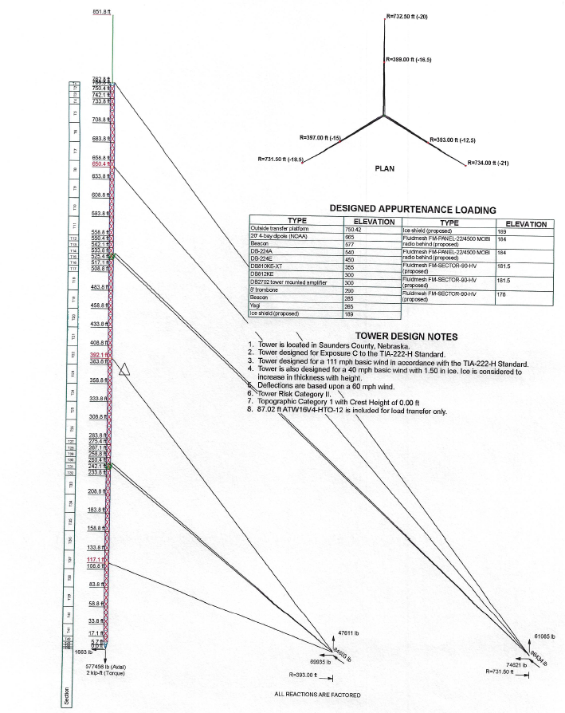
Diagram 2
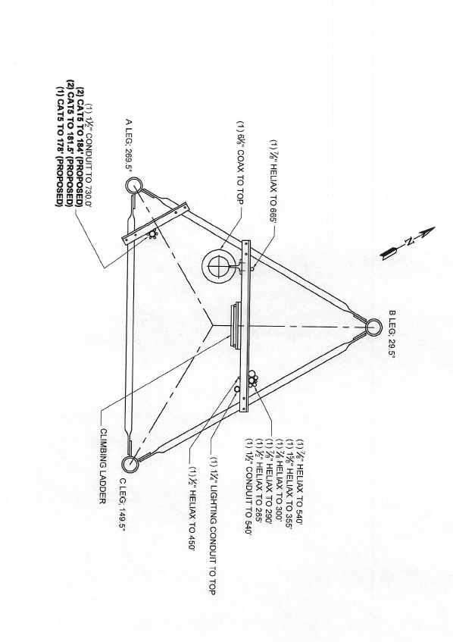

- PROJECT REQUIREMENTS
The project will be completed in three (3) phases.

PHASE 1) Install New UHF-27 Aux Antenna and Transmission Line on West side of transmission tower.
Antenna Model: Dielectric DLP12B UHF TV BROADCAST ANTENNA WITH ELLIPTICAL POLARIZATION
Mounting: Side Mounted
Environmental Protection: Slot Cover Only
Antenna Height: 23.6 ft ( 7.2 m)
Weight: 115 lb (53 kg) Excludes Mounts
Effective Projected Area: 16 ft² (1.5 m²)
Mount: Standard Mount 1 1/4 TO 4 1/2 INCH LEG
Mounting Height on Tower: Approx 550 ft above ground level
Mounting Side of Tower: West Side
Transmission Line: 1-5/8" AIR-DIELECTRIC COAXIAL CABLE, HCA158-50JM
Line Length: 650 Feet Total (550 ft vertical + 100 ft horizontal)
For reference see Diagrams 3 below

Diagram 3
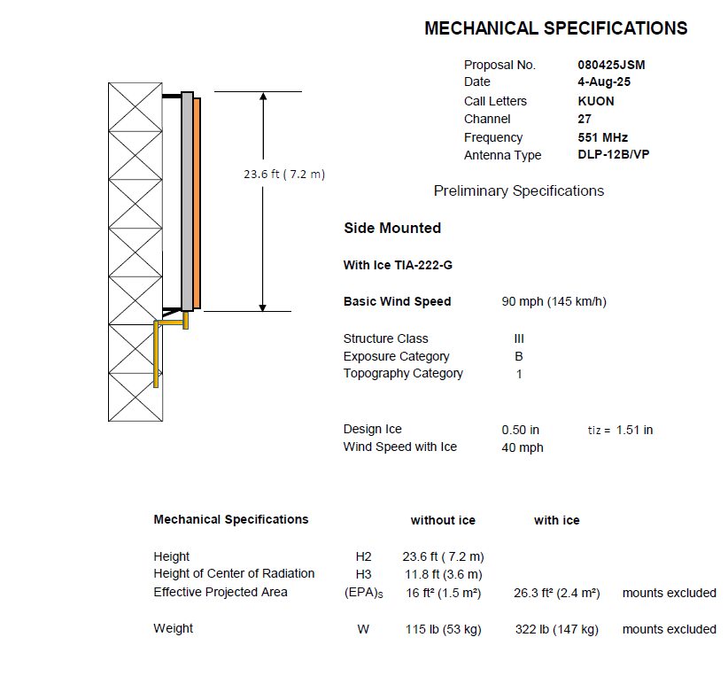

AUX ANTENNA - MANUFACTURER (DIELECTRIC) SUPPLIED ITEMS
The following items listed in Exhibit A were supplied by the manufacturer with the purchase of the new antenna. The awarded contractor will be responsible to supply any additional installation materials needed that are not listed in Exhibit A below.

Exhibit A
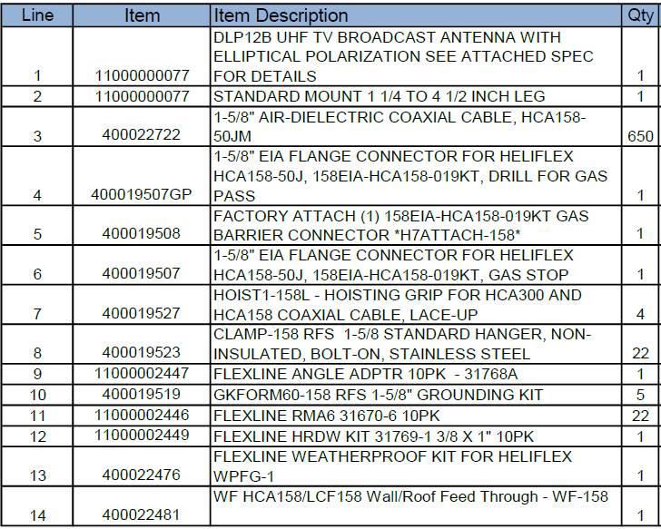

PHASE 2) Remove and dispose of Old VHF-12 Main Antenna and Transmission Line from transmission tower
Antenna Model: Andrew ATW16V5-HTO-12 Trasar Top Mounted VHF Antenna
Antenna Height: 85.5 ft tall incl 3 ft lighting protection
Weight: Approx 23,500 lbs
Mounted Height: Approx 850 ft above ground level (at top of tower)
Mounting flange 32 x 1.25" bolts on 36.00 dia B.C
Transmission Line: 6” Rigid Coax
Line Length: Approx 900 Feet total (800 ft vertical + 100 ft horizontal)

PHASE 3) Install New VHF-27 Main Antenna and Transmission Line at top of transmission tower
Antenna Model: TFU-28ETT-VP-R O6 UHF CH 27 ELLIPTICALLY POLARIZED TOP MOUNT ANTENNA WITH FULL RADOME
Mounting: Top of Stack
Environmental Protection: Full Radome
Antenna Height: 55 ft (16.8m) less Lightning Protector, 58 ft (17.7m) with Lightning Protector
Antenna Weight: 6700 lb (3t)
Effective Projected Area: 62.7 ft² (5.8m²)
Transmission Line: 6” Rigid Coax
Line Length: 900 Feet Total (800 ft vertical + 100 ft horizontal)
For reference see Diagrams 4 below

MAIN ANTENNA DIAGRAM 4
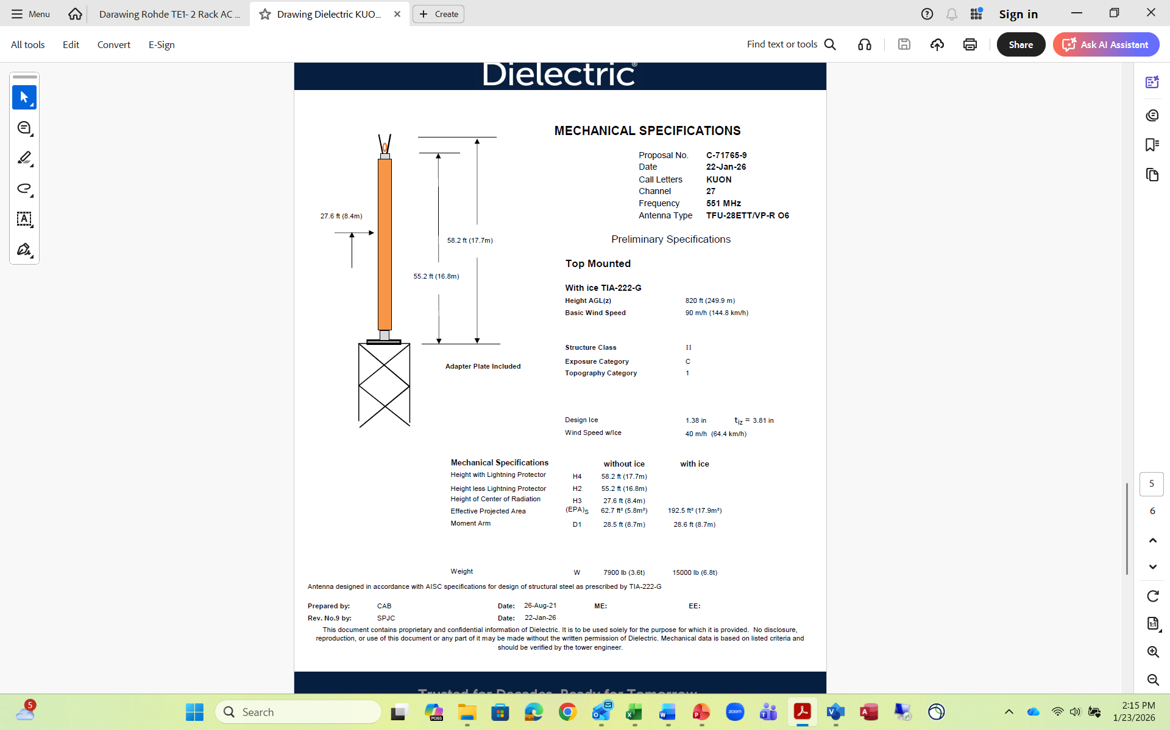

MAIN ANTENNA - MANUFACTURER (DIELECTRIC) SUPPLIED ITEMS
The following items listed in Exhibit B were supplied by the manufacturer with the purchase of the new antenna. The awarded contractor will be responsible to supply any additional installation materials needed that are not listed in Exhibit B below.

Exhibit B
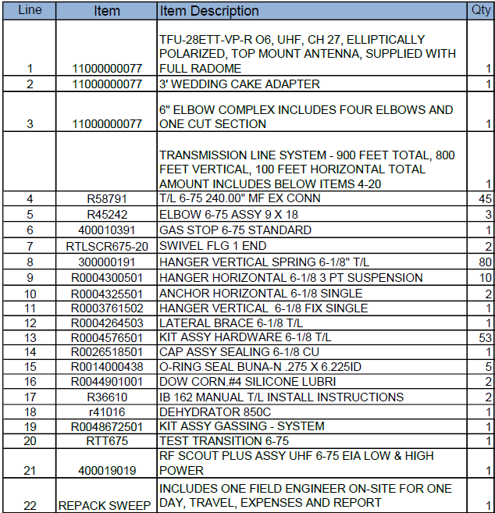
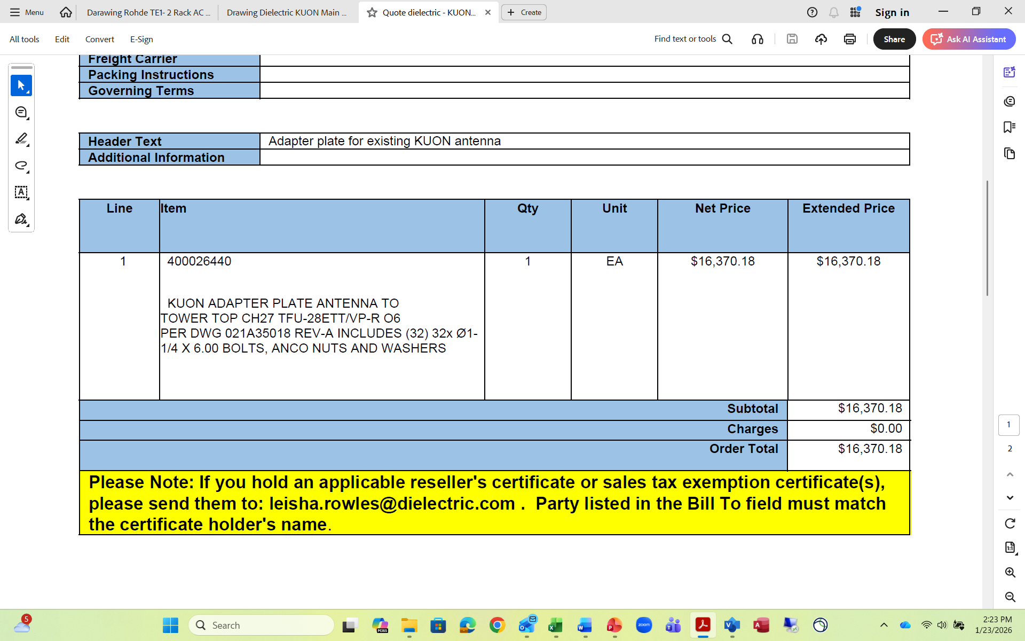

- TIMELINE REQUIREMENTS
Project must be completed no later than July 31, 2026
Project PHASE 1 to be priced separately from PHASES 2 and 3
At NETC’s option PHASE 1 to be executed up to six months earlier than PHASES 2 and 3
Project PHASES 2 and 3 to be executed together in PHASE 2 then PHASE 3 order

Accept All Timeline Requirements Within Section as Written  (Initial) | Exceptions Taken to Timeline Requirements Within Section as Written  (Initial) | Exceptions:  (Bidder must note the specific requirement, an explanation of why the bidder took exception to the requirement, and provide an alternative option to the specific requirement within the solicitation response.)

- SCOPE OF WORK
On NETC’s KUON-TV transmission tower in Ithaca, Nebraska, the awarded contractor shall first install a smaller UHF-27 Aux antenna and transmission line on side of transmission tower, then remove the old existing VHF-12 Main antenna and transmission line from top of tower, and finally install a new UHF-27 Main antenna, and transmission line on top of tower.
The awarded contractor is responsible for disassembly and removal of existing Main Antenna and Transmission Line from site.
The awarded contractor is responsible for preparing an area with support system (e.g. cradle) at KUON site for New Main Antenna to sit physically securely on ground, and when Main Antenna is delivered to KUON site by manufacturer, for offloading the Main Antenna to the prepared secure area support system.
Installation includes all brackets and other materials needed to permanently and safely mount new antennas and Line. See Main and Aux Antenna Manufacturer Supplied Items (Exhibits A and B) in Project Requirements for reference.
Bidder to describe rigging procedure and processes for all installation phases. Gin pole rigging is the preferred rigging method; however, alternative rigging methods will be considered, but must be described by Bidder in detail with explanation of how alternate rigging is superior to gin pole method and capable of safely lifting and handling up to 24,000 pounds.

NETC must sign off on all tested Antenna/Line functionality including pressure testing and antenna/line tuning before any rigging is removed and relevant Project Step is considered complete.
Testing to be done in coordination between Antenna/Line manufacturer, Contractor, and NETC.
Should there be a conflict regarding acceptable completion of performance testing, the State’s opinion shall prevail.

Accept All Scope of Work Requirements Within Section as Written  (Initial) | Exceptions Taken to Scope of Work  Requirements Within Section as Written  (Initial) | Exceptions:  (Bidder must note the specific requirement, an explanation of why the bidder took exception to the requirement, and provide an alternative option to the specific requirement within the solicitation response.)

- WORK PLAN
PHASE 1 is required to be completed separately from PHASE 2 and PHASE 3.

PHASE 1) Install New UHF-27 Aux Antenna and Aux Transmission Line on side of transmission tower
- Coordinate and Accept delivery of Aux Antenna and Aux Transmission Line from Manufacturer (Dielectric)
- Rig KUON-TV tower for safe climbing and installation of side mounted Aux Antenna and Line
- Climb tower and Install Aux Antenna and antenna end of Aux Transmission Line at approx. 550 ft AGL
- Plumb Aux Transmission Line from new Aux Antenna either to ground-located Aux Transmitter or to a point designated by NETC
- Perform Antenna and Transmission Line pressurization and pressure testing.
- In conjunction with NETC and antenna manufacturer, facilitate antenna and transmission and line performance testing as needed by NETC, including assist with line sweep and antenna tune.
- Remove PHASE 1 rigging when Aux Antenna and Line testing is complete (unless Step 2 is imminent in which case leave relevant rigging in place as needed for Step 2)

PHASE 2) Remove Old VHF-12 Main Antenna and Old Transmission Line from top of transmission tower
- Rig tower for safe climbing and with a gin pole capable of lifting and removing the existing 23,500 pound, 85.5 foot VHF-12 Antenna from the top of the 234.7 meter guyed tower
- Remove existing VHF Main Antenna and Transmission Line
- Dispose old VHF Main Antenna and Transmission Line (remove from site)
- Leave PHASE 2 rigging in place for PHASE 3

PHASE 3} Install New VHF-27 Main Antenna and Transmission Line at top of transmission tower
- Prepare an area with a support system (e.g. a cradle) at KUON site for New Main Antenna to sit physically securely on ground
- Coordinate and Accept delivery of Main Antenna and Main Transmission Line from Manufacturer (Dielectric)
- When Main Antenna is delivered to KUON site by manufacturer, offload the Main Antenna to prepared physically secure support system.
- Climb tower and Install New Main Antenna, Adaptor Plate and Transmission Line
- Install top lighting beacon and wiring, provided by NETC, at top of new antenna.
- Plumb Main Transmission Line from new Main Antenna either to ground-located Main Transmitter or to a point designated by NETC
- Perform antenna and line pressurization and pressure testing.
- In conjunction with NETC and antenna manufacturer, facilitate antenna and transmission and line testing as needed by NETC, including assist with line sweep and antenna tune.
- Perform plumb and tension on tower to manufacturers recommendations
- Remove Rigging including gin pole when installation and testing complete
- Load equipment, remove all construction debris and de-mobilize

Accept All Work Plan Requirements Within Section as Written  (Initial) | Exceptions Taken to Work Plan  Requirements Within Section as Written  (Initial) | Exceptions:  (Bidder must note the specific requirement, an explanation of why the bidder took exception to the requirement, and provide an alternative option to the specific requirement within the solicitation response.)

- TECHNICAL REQUIREMENTS
Vendor will comply with all NETC site restrictions and regulations.

Vendor is responsible for adherence to all safety regulation and installation requirements that include, but are not limited to the following:
- Climber Certification Program
- Site Safety Plan (emergency phone numbers, site address, etc.)
- Man-Rated Hoist
- Hard Hat Usage
- Crew has a trained rigger to oversee site operations.
- Crew has a written rigging plan.

Vendor is responsible for adherence to OSHA’s best recommended practices:
- https://www.osha.gov/Publications/OSHA3877.pdf

Vendor understands NETC reserves the right to reject bids based on previous work performed on NETC tower(s)

Accept All Technical Requirements Within Section as Written  (Initial) | Exceptions Taken to Technical  Requirements Within Section as Written  (Initial) | Exceptions:  (Bidder must note the specific requirement, an explanation of why the bidder took exception to the requirement, and provide an alternative option to the specific requirement within the solicitation response.)

- PROJECT PLANNING AND MANAGEMENT
The awarded contractor shall establish a primary contact person within their proposal, including the contact’s name, address, phone and fax numbers, and email address.

The awarded contractor shall provide a project implementation plan including but not limited to installation, removal, and phased approach including timelines with milestones for completing the project.

The awarded contractor will schedule a conference call within ten (10) working days of contract finalization with the NETC Project Manager and designees to set a regular weekly conference call which will take place for the duration of the contract.

The awarded contractor will work with NETC Project Manager to establish a workable timeline for planning, installation, implementation, integration, configuration, and testing of the system or systems deployed.

The bidder should present a detailed description of its proposed approach to the management of this project.

All service shall be coordinated in advance with the NETC project manager during normal business hours, Monday through Friday, 8:30 AM through 4:30 PM CST.

Precaution shall be taken by the awarded contractor and it’s designees to prevent any interruption of NETC broadcast and non-broadcast services. All installation, integration and implementation work to be performed will be coordinated with the NETC Project Manager who will coordinate with NET television and radio operations, content creation and production departments.

Awarded contractor will be required to provide the name of the Tower Installation Crew company that will be used for this project to the NETC Project Manager for approval prior to the beginning of work.

A copy of the final inspection report, test results, services performed, and recommended improvements is to be left on site with NETC Project Manager or designee upon completion of service and will be submitted with the final invoice for each phase.

Accept All Project Planning and Management Requirements Within Section as Written  (Initial) | Exceptions Taken to Project Planning and Management Requirements Within Section as Written  (Initial) | Exceptions:  (Bidder must note the specific requirement, an explanation of why the bidder took exception to the requirement, and provide an alternative option to the specific requirement within the solicitation response.)

- EVALUATE CURRENT PROJECT ENVIRONMENT
The awarded contractor will coordinate and schedule an on-site visit to evaluate the project environment and work
with NETC Project Manager and designees to determine the best methods and mechanisms for installation,
implementation, integration, configuration, and testing of the systems deployed.

- PROVIDE POST IMPLEMENTATION SUPPORT
- Should NETC Testing following STEPS 1 or 3 result in test failure, vendor will re-climb as necessary and at no additional cost to support resolution of problem.

- DELIVERABLES

SERVICES
  - New Aux UHF Antenna and Transmission Line Installation
  - Old VHF Main Antenna Removal and Disposal
  - New UHF Main Antenna and Transmission Line Installation

MATERIALS
- Any additional Permanent Mounting Items needed that are NOT Manufacturer (Dielectric) Supplied
- SOLICITATION RESPONSE INSTRUCTIONS
This section documents the requirements that should be met by bidders in preparing the Corporate Overview and Technical Response portions of the solicitation response. The solicitation Cost Sheet template should be completed by bidders and submitted as a separate attachment with their solicitation response. Bidders should identify the subdivisions of “Project Description and Scope of Work” clearly in their solicitation response; failure to do so may result in disqualification. Failure to respond to a specific requirement may be the basis for elimination from consideration during the State’s comparative evaluation.

Solicitation responses are due by the date and time shown in the Schedule of Events. Content requirements for the Corporate Overview and Technical Response are presented separately in the following subdivisions:

- SOLICITATION RESPONSE SUBMISSION

    - CORPORATE OVERVIEW
                - The Corporate Overview section of the solicitation response should consist of the following subdivisions:

      - BIDDER IDENTIFICATION AND INFORMATION
The bidder should provide the full company or corporate name, address of the company's headquarters, entity organization (corporation, partnership, proprietorship), state in which the bidder is incorporated or otherwise organized to do business, year in which the bidder first organized to do business and whether the name and form of organization has changed since first organized.

      - FINANCIAL STATEMENTS
The bidder should provide financial statements applicable to the firm. If publicly held, the bidder should provide a copy of the corporation's most recent audited financial reports and statements, and the name, address, and telephone number of the fiscally responsible representative of the bidder’s financial or banking organization.

If the bidder is not a publicly held corporation, either the reports and statements required of a publicly held corporation, or a description of the organization, including size, longevity, client base, areas of specialization and expertise, and any other pertinent information, should be submitted in such a manner that solicitation evaluators may reasonably formulate a determination about the stability and financial strength of the organization. Additionally, a non-publicly held firm should provide a banking reference.

The bidder must disclose any and all judgments, pending or expected litigation, or other real or potential financial reversals, which might materially affect the viability or stability of the organization, or state that no such condition is known to exist.

The State may elect to use a third party to conduct credit checks as part of the corporate overview evaluation.

      - CHANGE OF OWNERSHIP
If any change in ownership or control of the company is anticipated during the twelve (12) months following the solicitation response due date, the bidder should describe the circumstances of such change and indicate when the change will likely occur. Any change of ownership to an awarded bidder(s) will require notification to the State.

      - OFFICE LOCATION
The bidder’s office location responsible for performance pursuant to an award of a contract with the State of Nebraska should be identified.

      - RELATIONSHIPS WITH THE STATE
The bidder should describe any dealings with the State over the previous five (5) years. If the organization, its predecessor, or any Party named in the bidder’s solicitation response has contracted with the State, the bidder should identify the contract number(s) and/or any other information available to identify such contract(s). If no such contracts exist, so declare.

      - BIDDER’S EMPLOYEE RELATIONS TO STATE
If any Party named in the bidder’s solicitation response is or was an employee of the State within the past twenty-four (24) (months, identify the individual(s) by name, State agency with whom employed, job title or position held with the State, and separation date. If no such relationship exists or has existed, so declare.

If any employee of any agency of the State of Nebraska is employed by the bidder or is a subcontractor to the bidder, as of the due date for solicitation response submission, identify all such persons by name, position held with the bidder, and position held with the State (including job title and agency). Describe the responsibilities of such persons within the proposing organization. If, after review of this information by the State, it is determined that a conflict of interest exists or may exist, the bidder may be disqualified from further consideration in this solicitation. If no such relationship exists, so declare.

      - CONTRACT PERFORMANCE
If the bidder or any proposed subcontractor has had a contract terminated for default during the past three (3) years, all such instances must be described as required below. Termination for default is defined as a notice to stop performance delivery due to the bidder’s non-performance or poor performance, and the issue was either not litigated due to inaction on the part of the bidder or litigated and such litigation determined the bidder to be in default.

It is mandatory that the bidder submit full details of all termination for default experienced during the past three (3) years, including the other Party's name, address, and telephone number. The response to this section must present the bidder’s position on the matter. The State will evaluate the facts and will score the bidder’s solicitation response accordingly. If no such termination for default has been experienced by the bidder in the past three (3) years, so declare.

If at any time during the past three (3) years, the bidder has had a contract terminated for convenience, non-performance, non-allocation of funds, or any other reason, describe fully all circumstances surrounding such termination, including the name and address of the other contracting Party.

      - SUMMARY OF BIDDER’S CORPORATE EXPERIENCE
The bidder should provide a summary matrix listing the bidder’s previous projects similar to this Solicitation in size, scope, and complexity. The State will use no more than three (3) narrative project descriptions submitted by the bidder during its evaluation of the solicitation response.

The bidder should address the following:

        - Provide narrative descriptions to highlight the similarities between the bidder’s experience and this Solicitation. These descriptions should include:

          - The time period of the project,
          - The scheduled and actual completion dates,
          - The bidder’s responsibilities,
          - For reference purposes, a customer name (including the name of a contact person, a current telephone number, a facsimile number, and e-mail address); and
          - Each project description should identify whether the work was performed as the prime Vendor or as a subcontractor. If a bidder performed as the prime Vendor, the description should provide the originally scheduled completion date and budget, as well as the actual (or currently planned) completion date and actual (or currently planned) budget.

        - Bidder and Subcontractor(s) experience should be listed separately. Narrative descriptions submitted for Subcontractors should be specifically identified as subcontractor projects.

        - If the work was performed as a subcontractor, the narrative description should identify the same information as requested for the bidders above. In addition, subcontractors should identify what share of contract costs, project responsibilities, and time period were performed as a subcontractor.

      - SUMMARY OF BIDDER’S PROPOSED PERSONNEL/MANAGEMENT APPROACH
The bidder should present a detailed description of its proposed approach to the management of the project.

The bidder should identify the specific professionals who will work on the State’s project if their company is awarded the contract resulting from this Solicitation. The names and titles of the team proposed for assignment to the State project should be identified in full, with a description of the team leadership, interface, and support functions, and reporting relationships. The primary work assigned to each person should also be identified.

The bidder should provide resumes for all personnel proposed by the bidder to work on the project. The State will consider the resumes as a key indicator of the bidder’s understanding of the skill mixes required to carry out the requirements of the Solicitation in addition to assessing the experience of specific individuals.

Resumes should not be longer than three (3) pages. Resumes should include, at a minimum, academic background and degrees, professional certifications, understanding of the process, and at least three (3) references (name, address, and telephone number) who can attest to the competence and skill level of the individual. Any changes in proposed personnel shall only be implemented after written approval from the State.

      - SUBCONTRACTORS
If the bidder intends to subcontract any part of its performance hereunder, the bidder should provide:

        - name, address, and telephone number of the subcontractor(s),
        - specific tasks for each subcontractor(s),
        - percentage of performance hours intended for each subcontract; and
        - total percentage of subcontractor(s) performance hours.

    - TECHNICAL RESPONSE
                - The Technical Response section of the solicitation response should consist of the following subsections:

      - Understanding of the project requirements;
      - Proposed development approach;
      - Technical requirements;
      - Detailed project work plan; and
      - Deliverables and due dates.

CONTRACTUAL AGREEMENT FORM
BIDDER MUST COMPLETE THE FOLLOWING

By signing this Contractual Agreement Form, the bidder guarantees compliance with the provisions stated in this solicitation and agrees to the terms and conditions unless otherwise indicated in writing and certifies that bidder is not owned by the Chinese Communist Party.
Per Nebraska’s Transparency in Government Procurement Act, Neb. Rev Stat § 73-603, DAS is required to collect statistical information regarding the number of contracts awarded to Nebraska Vendors. This information is for statistical purposes only and will not be considered for contract award purposes.

_____ NEBRASKA VENDOR AFFIDAVIT: Bidder hereby attests that bidder is a Nebraska Vendor. “Nebraska Vendor” shall mean any bidder who has maintained a bona fide place of business and at least one employee within this state for at least the six (6) months immediately preceding the posting date of this Solicitation. All vendors who are not a Nebraska Vendor are considered Foreign Vendors under Neb. Rev Stat § 73-603 (c).

_____ I hereby certify that I am a Resident disabled veteran or business located in a designated enterprise zone in accordance with Neb. Rev. Stat. § 73-107 and wish to have preference, if applicable, considered in the award of this contract.

_____ I hereby certify that I am a blind person licensed by the Commission for the Blind & Visually Impaired in accordance with Neb. Rev. Stat. § 71-8611 and wish to have preference considered in the award of this contract.
THIS FORM MUST BE SIGNED MANUALLY IN INK OR BY DOCUSIGN
COMPANY:
ADDRESS:
PHONE:
EMAIL:
BIDDER NAME & TITLE:
SIGNATURE:
DATE:
VENDOR COMMUNICATION WITH THE STATE CONTACT INFORMATION
(IF DIFFERENT FROM ABOVE)
NAME:
TITLE:
PHONE:
EMAIL:

